# Action Stage

Action stage allows interacting with other application by calling a specific function. It actually has the library in blueprism, which provides different functions so that user can use those functions to interact with other applications.

As given in below screen shot there are two dropdown fields –

* **Business Objects** - It is the field where user choose the library. Hence, library is referred to as business object.
* **Action -** will list all the functions of the library. Hence, function is referred to as Action.

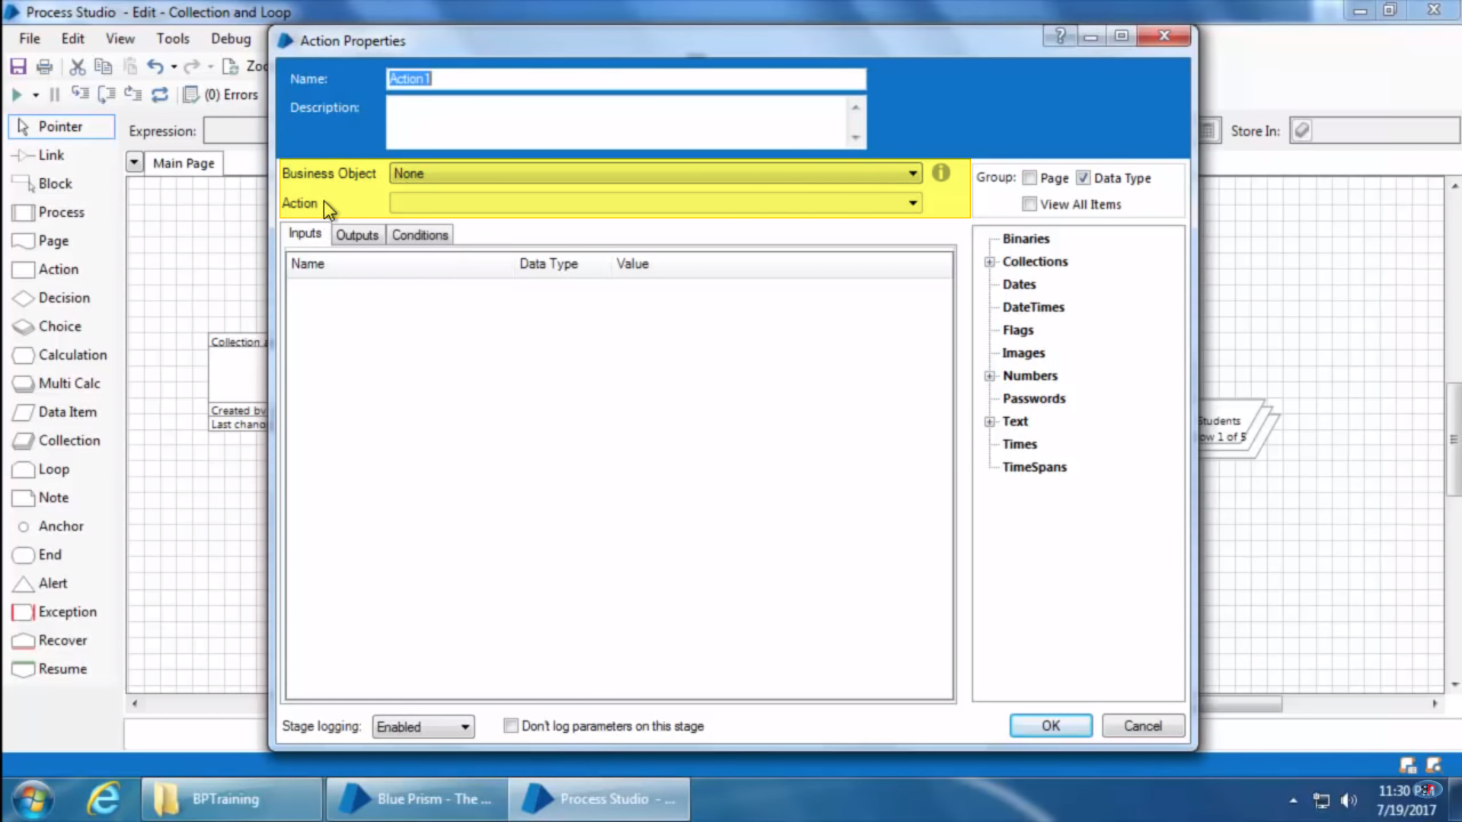

**Example** –

Let’s create a process to open an excel file and copy its data to a collection-

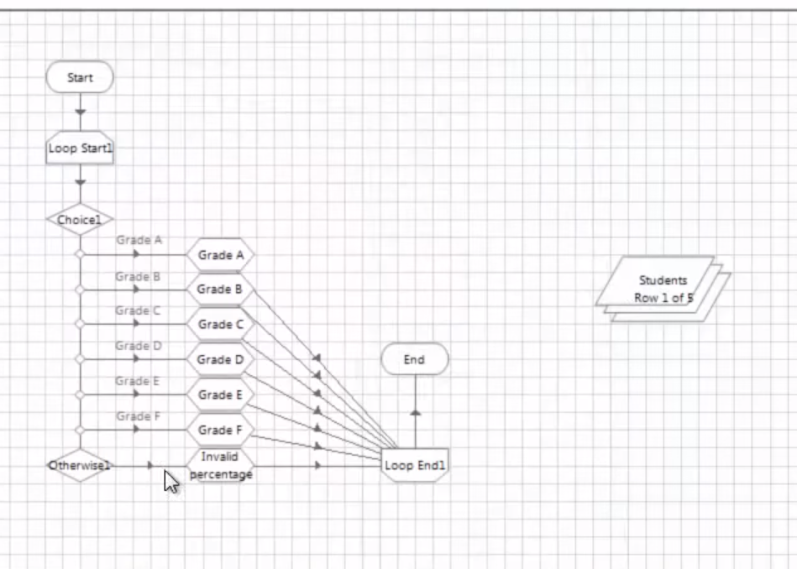

This is the initial state we have. We have students collection which is currently initialized with 5 values. So let’s clear out it’s initial values and assign values from excel to it.

Steps –

1. Drag and drop the action stage and open it–



1. Select MS Excel VBO from Business Objects -

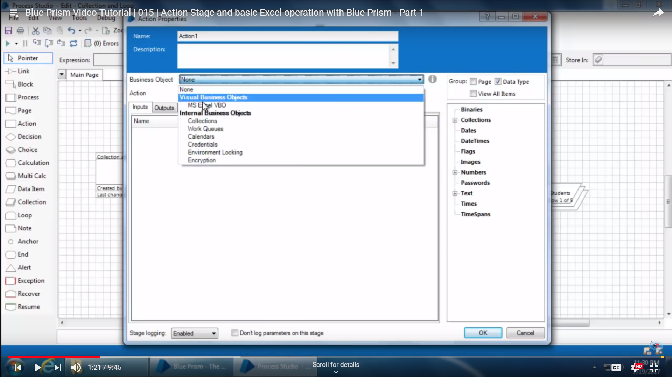

1. As soon as we select ms excel vbo from Action state action dropdown get’s enable and list all functions of ms excel vbo which are available to blueprism.

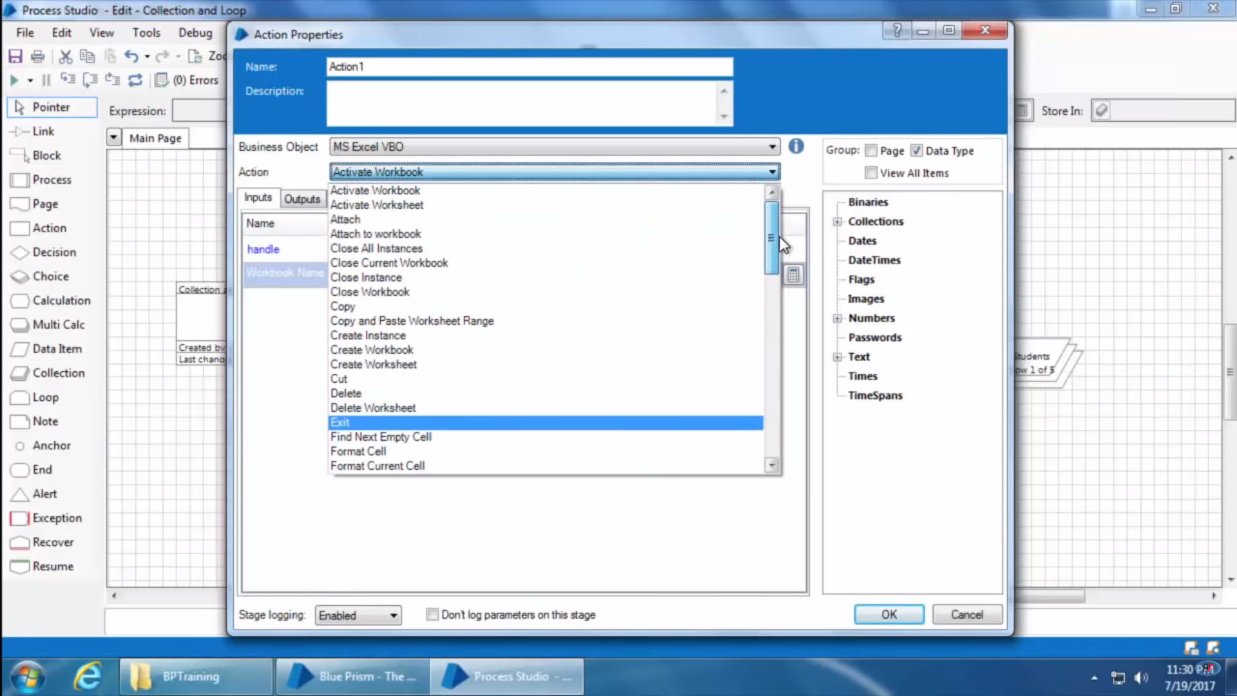

1. Let’s first create a excel instance in Action-1.
   1. Input parameter ask for excelEvents which specifies that shoud the excel events should be true when excel is opened or not.
   2. Output parameter ask for handle dataset. Whenever excel instance is created it assign a handle to a dataset so if further you have multiple excels opened so you can identify excel using that handle of excel instance. Drag a dataset to canvas or else click button in store in field, will handle a dataset automatically on canvas and will store handle to it.

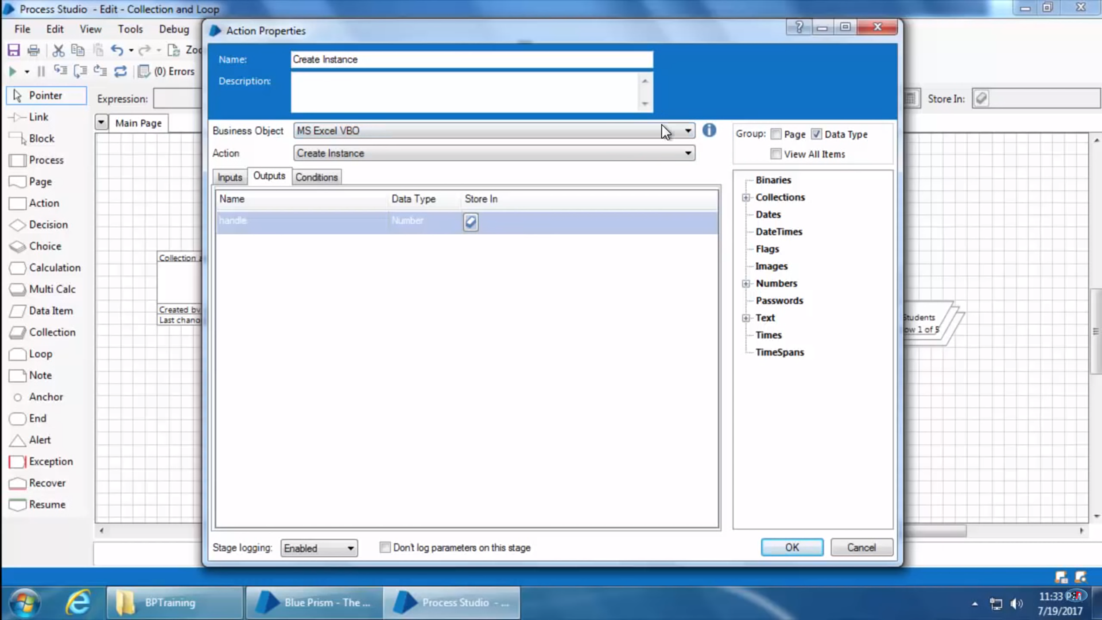

For different actions of excel we need to use separate action stages. Like one action to create instance of excel and next to open excel file and next to perform any action if needed such like that.

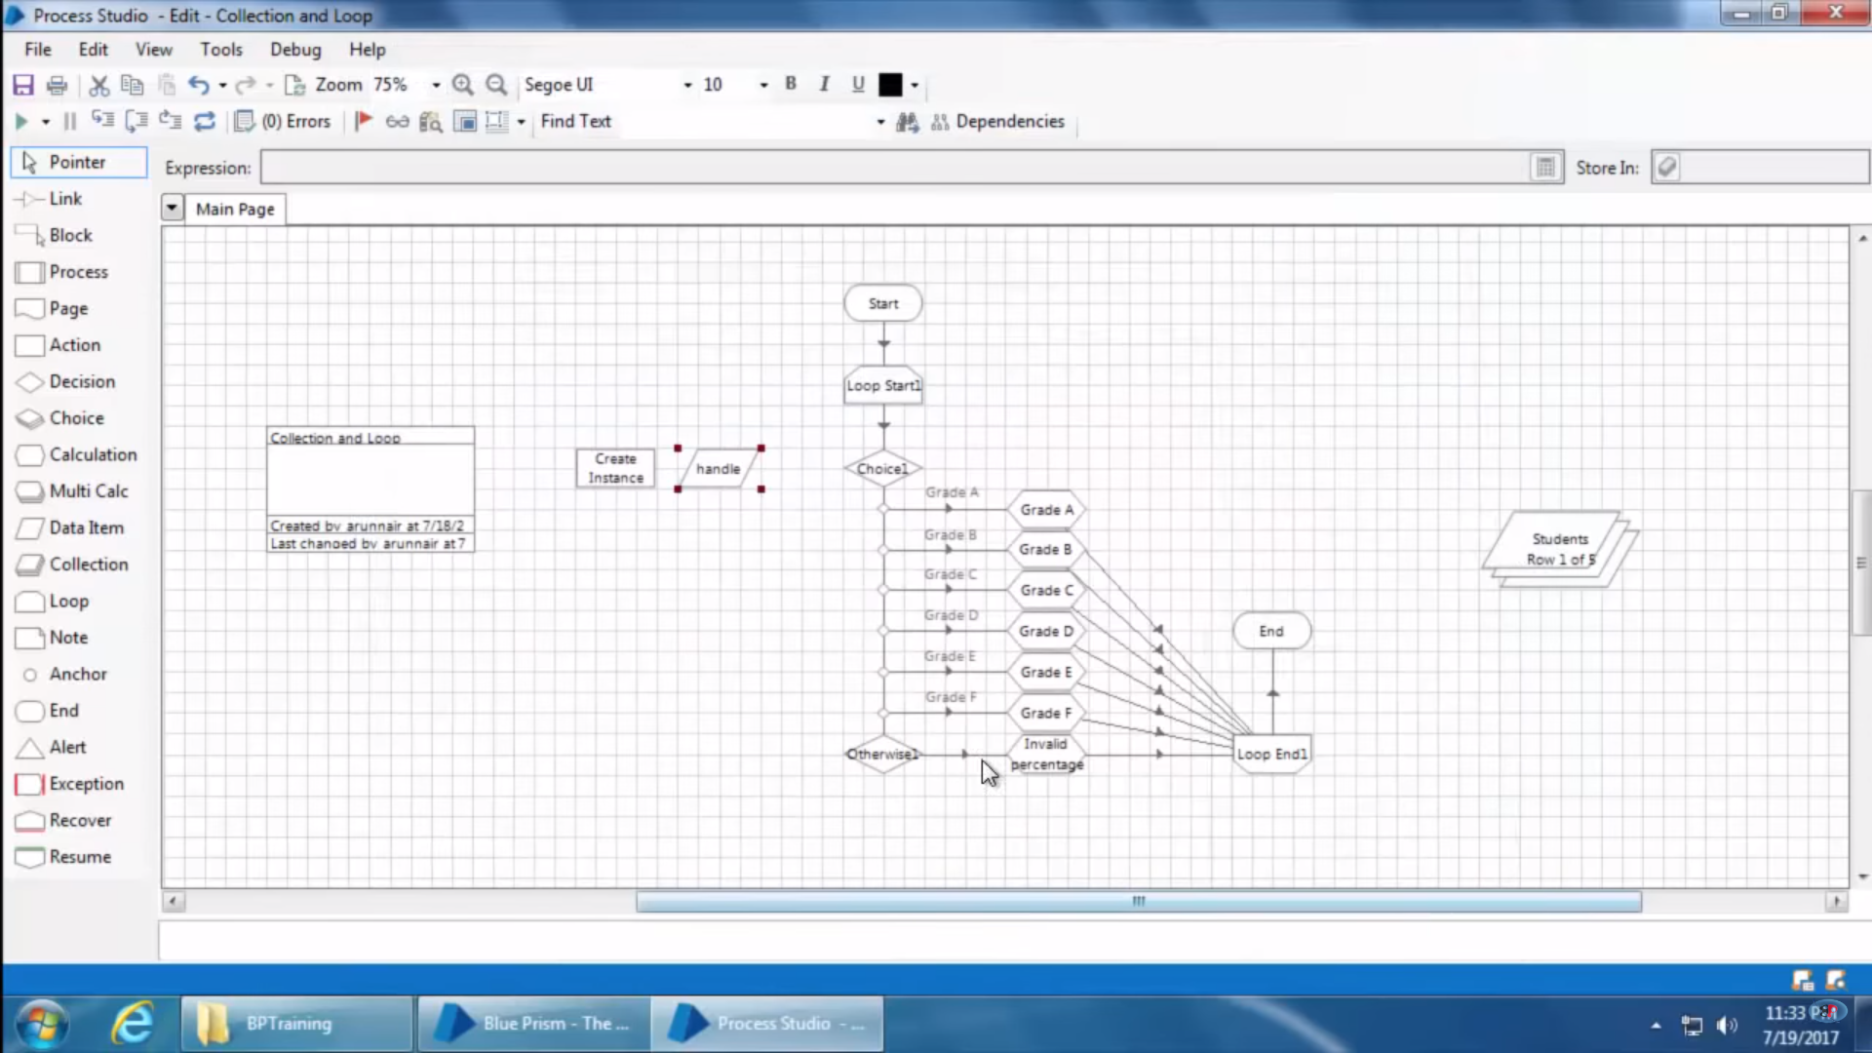

1. Drag another action and open it, it’s for opening file in excel –
   1. Input Parameter – Takes Handle, created in create excel instance earlier. And file path.
   2. Output Parameter – Takes a dataset named workbook to store workbook name there.

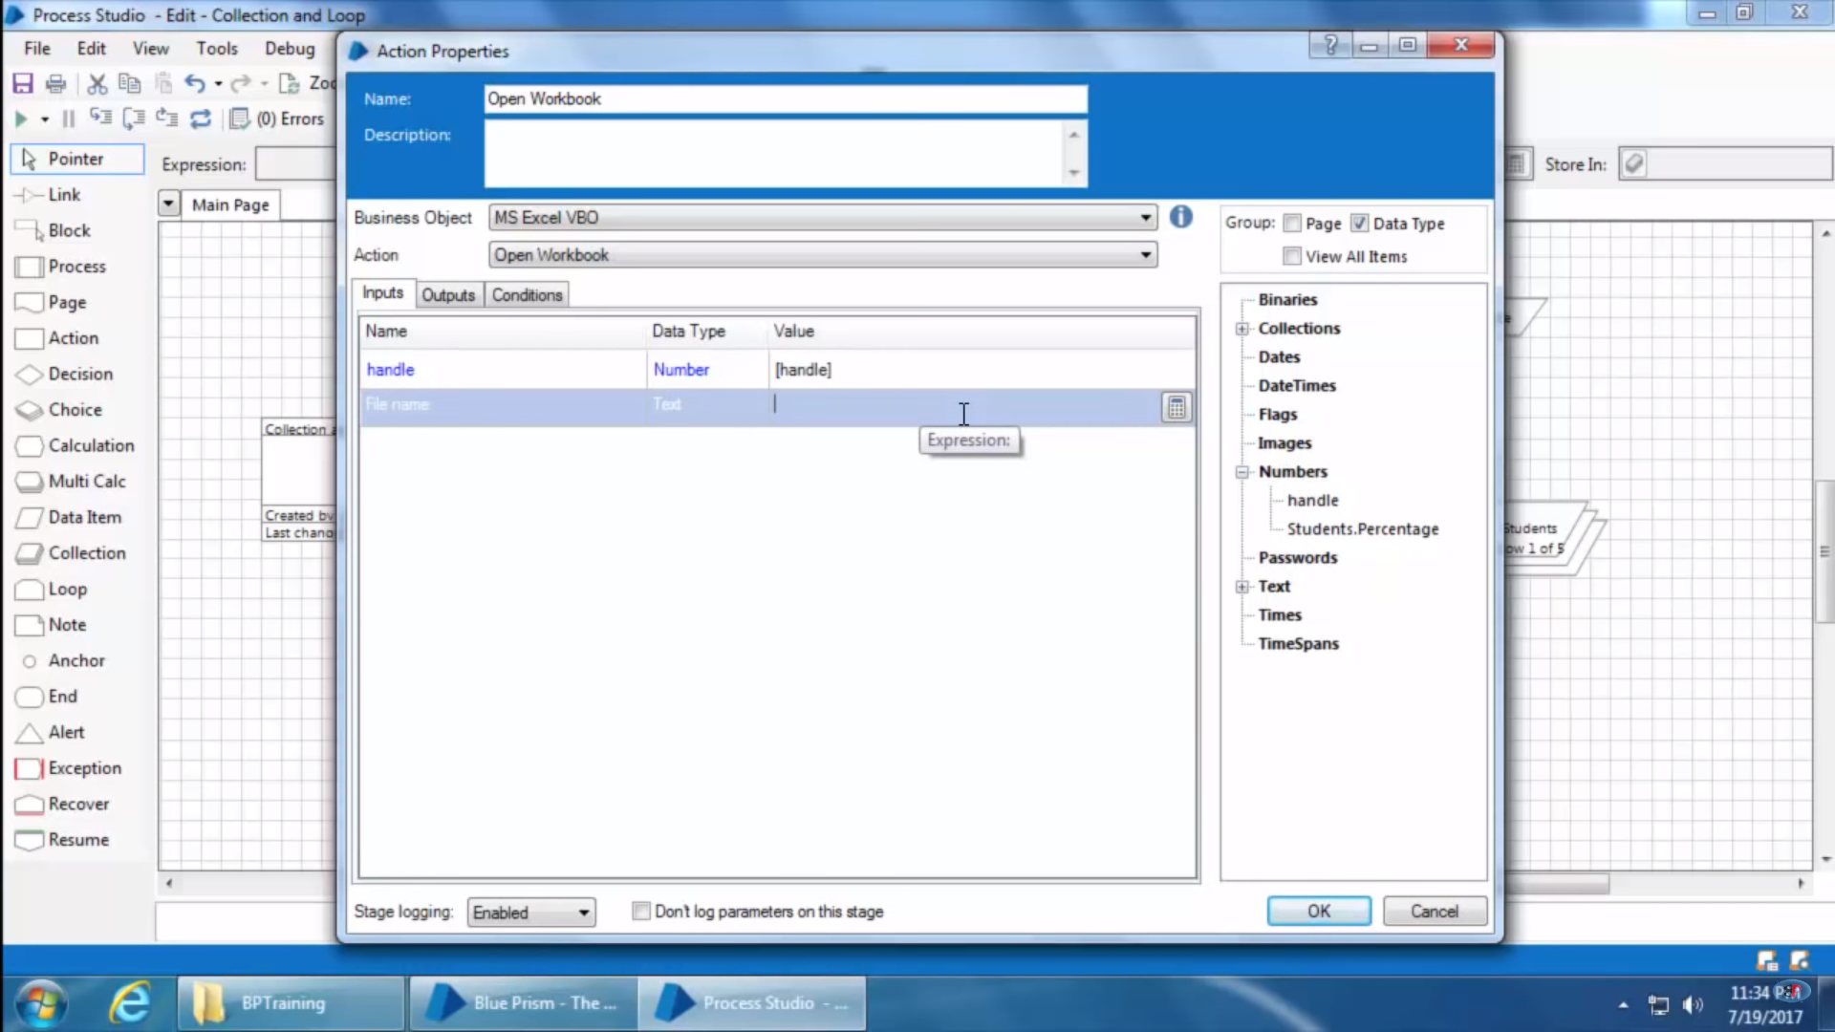

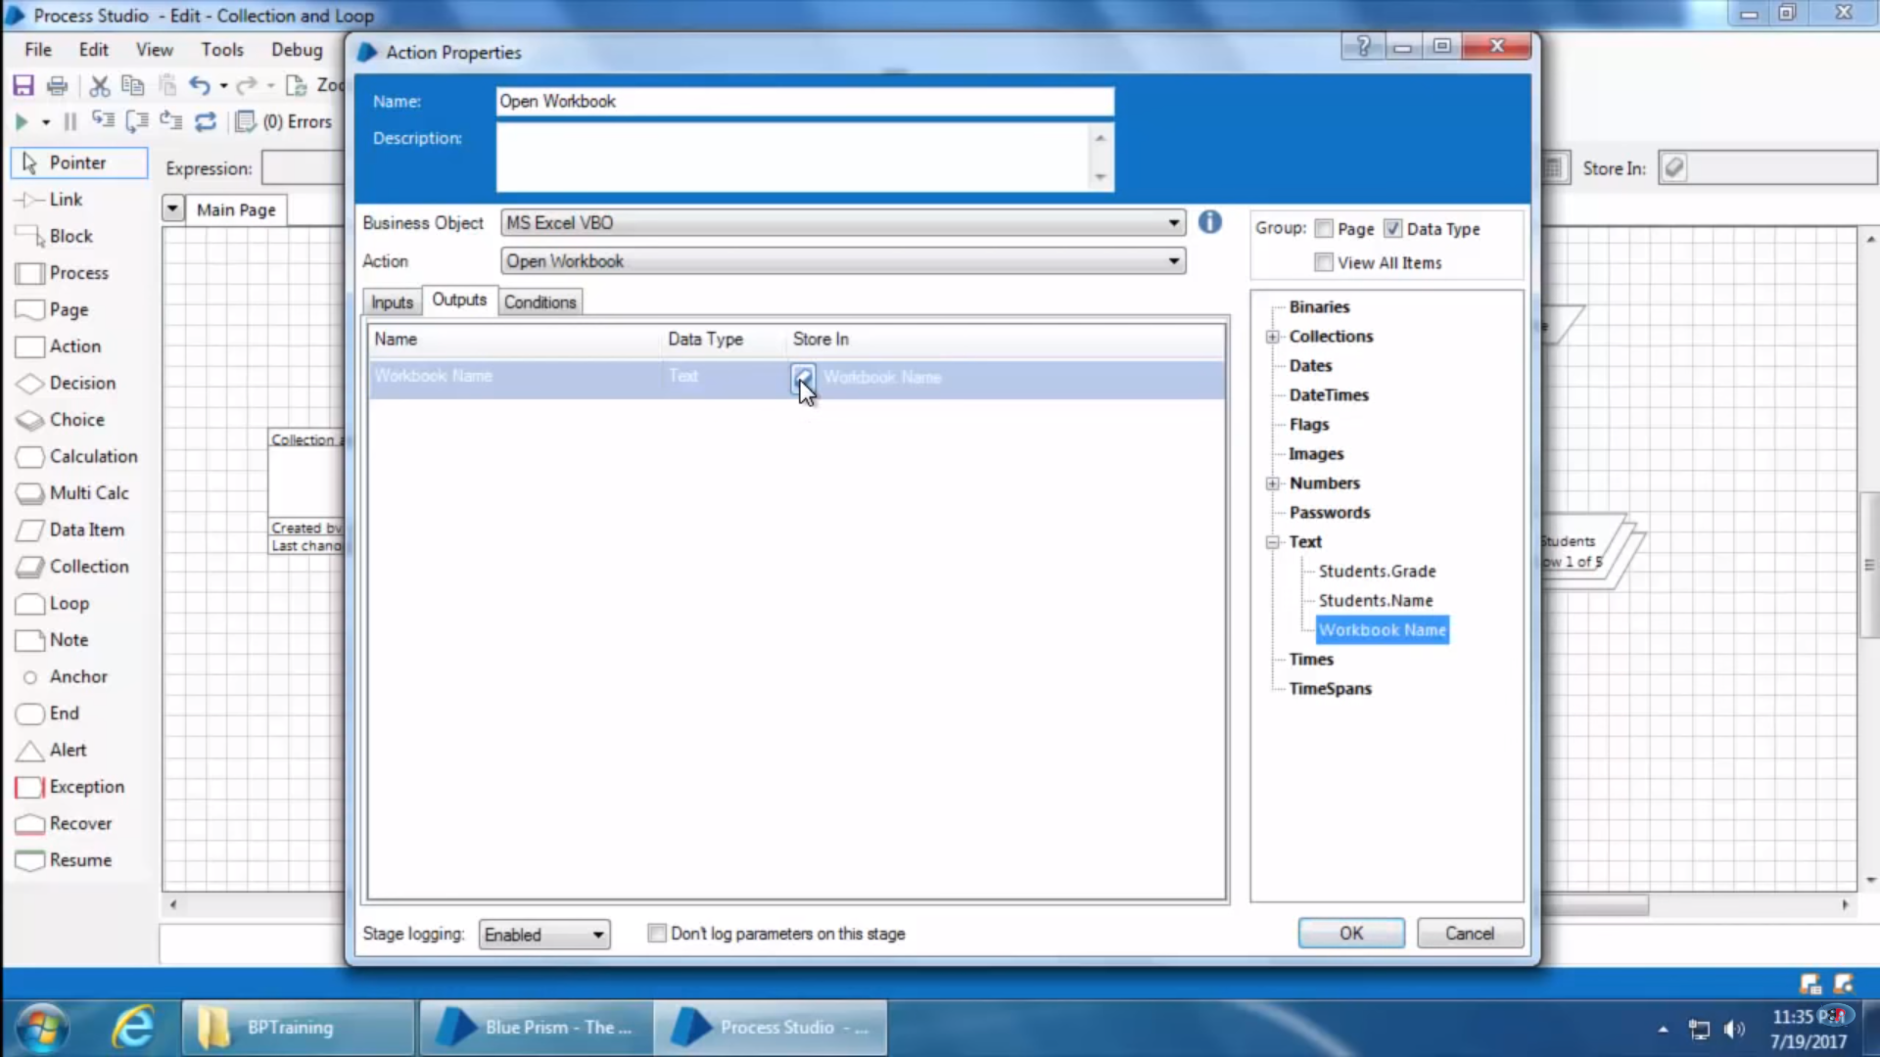

1. Putting another Action stage to insert excel data to collection –

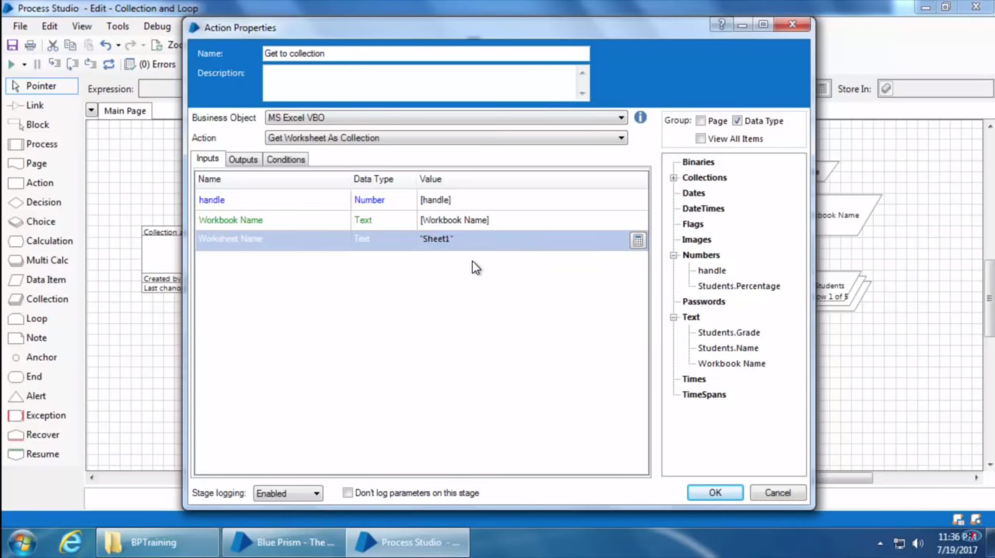

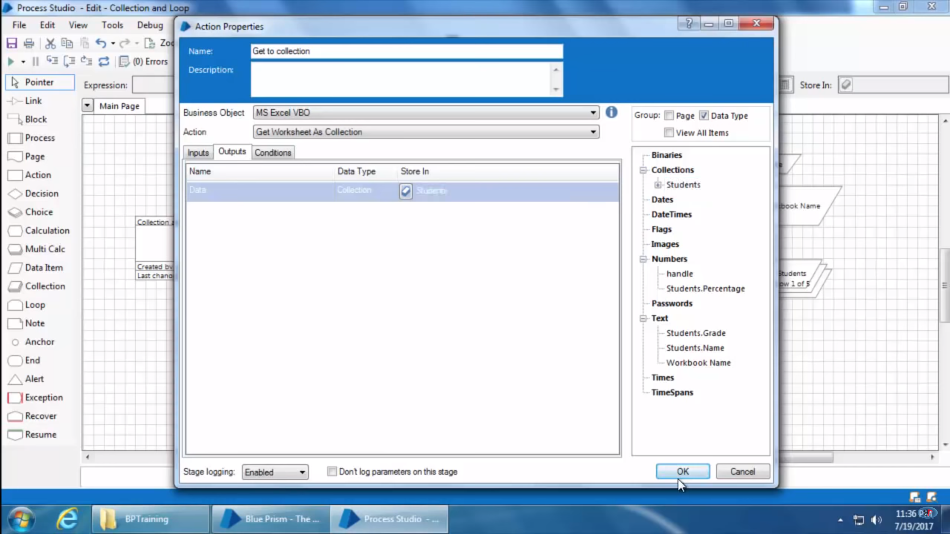

1. This is how it looks like finally –

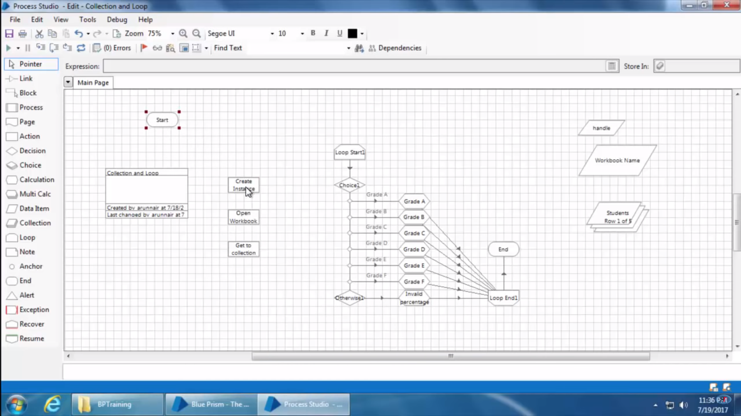

1. Joined all stages –

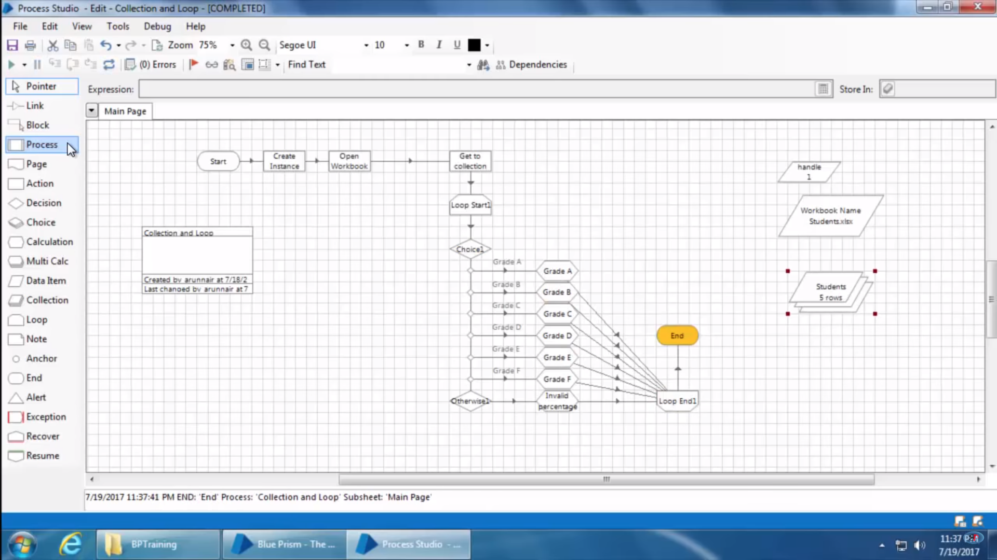

1. When this process is run, excel is not visible however it runs in background.

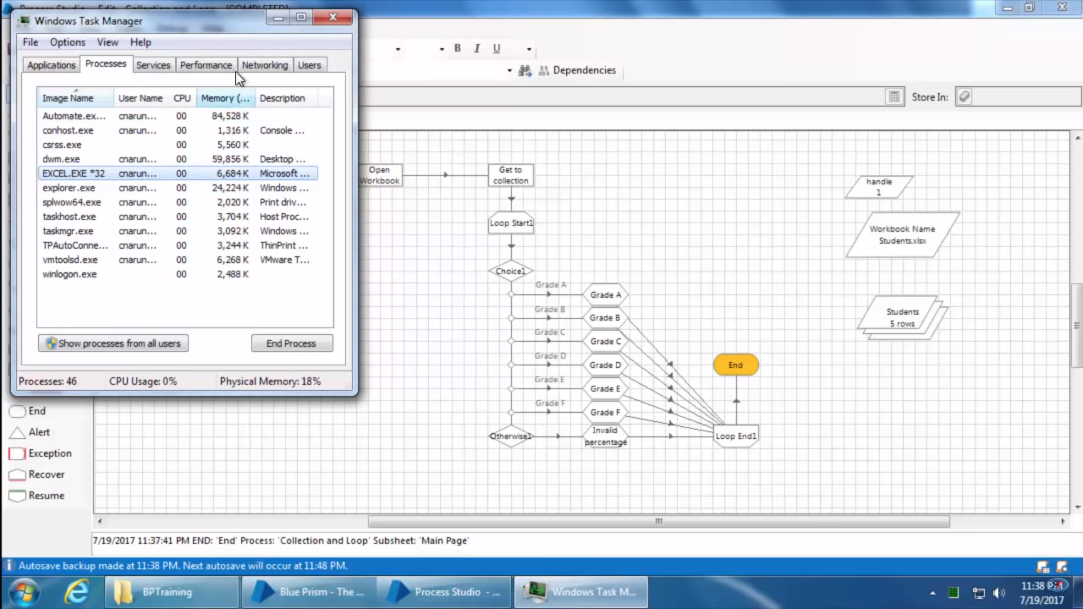

Hence To show excel when this process is ran we need to call one more action stage to show it.

1. Drag a new Action stage and select show inside action.

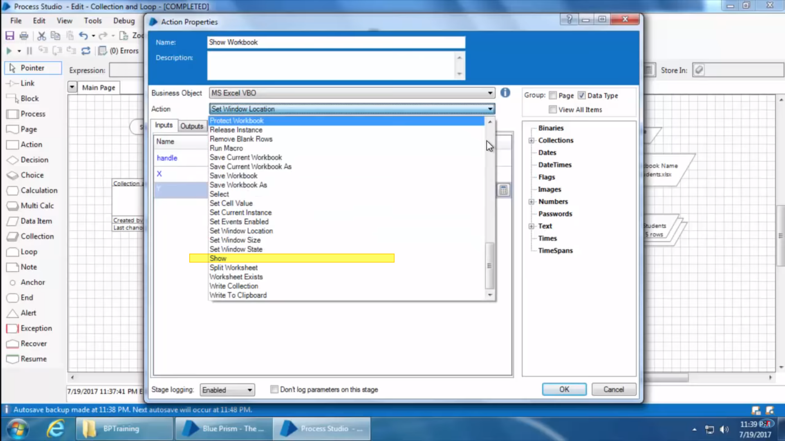

It takes the handle to identify the excel instance –

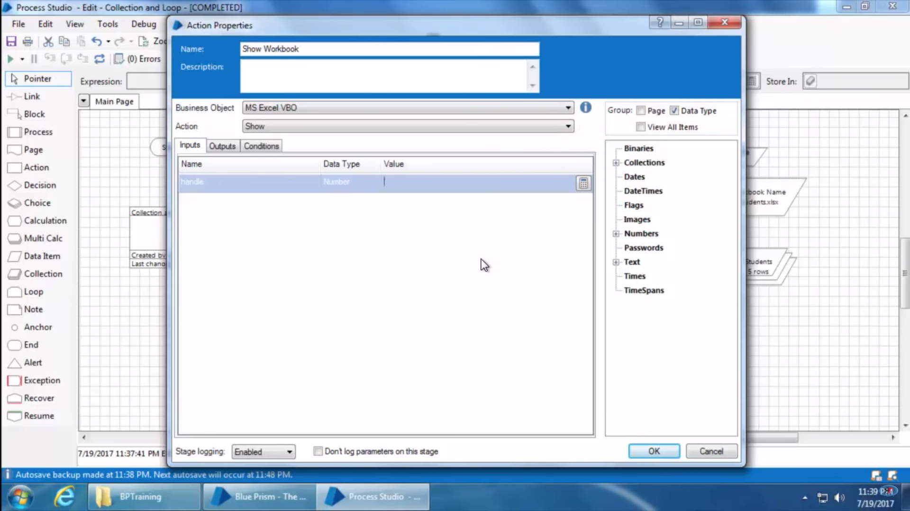

1. The complete process is looks something like this –

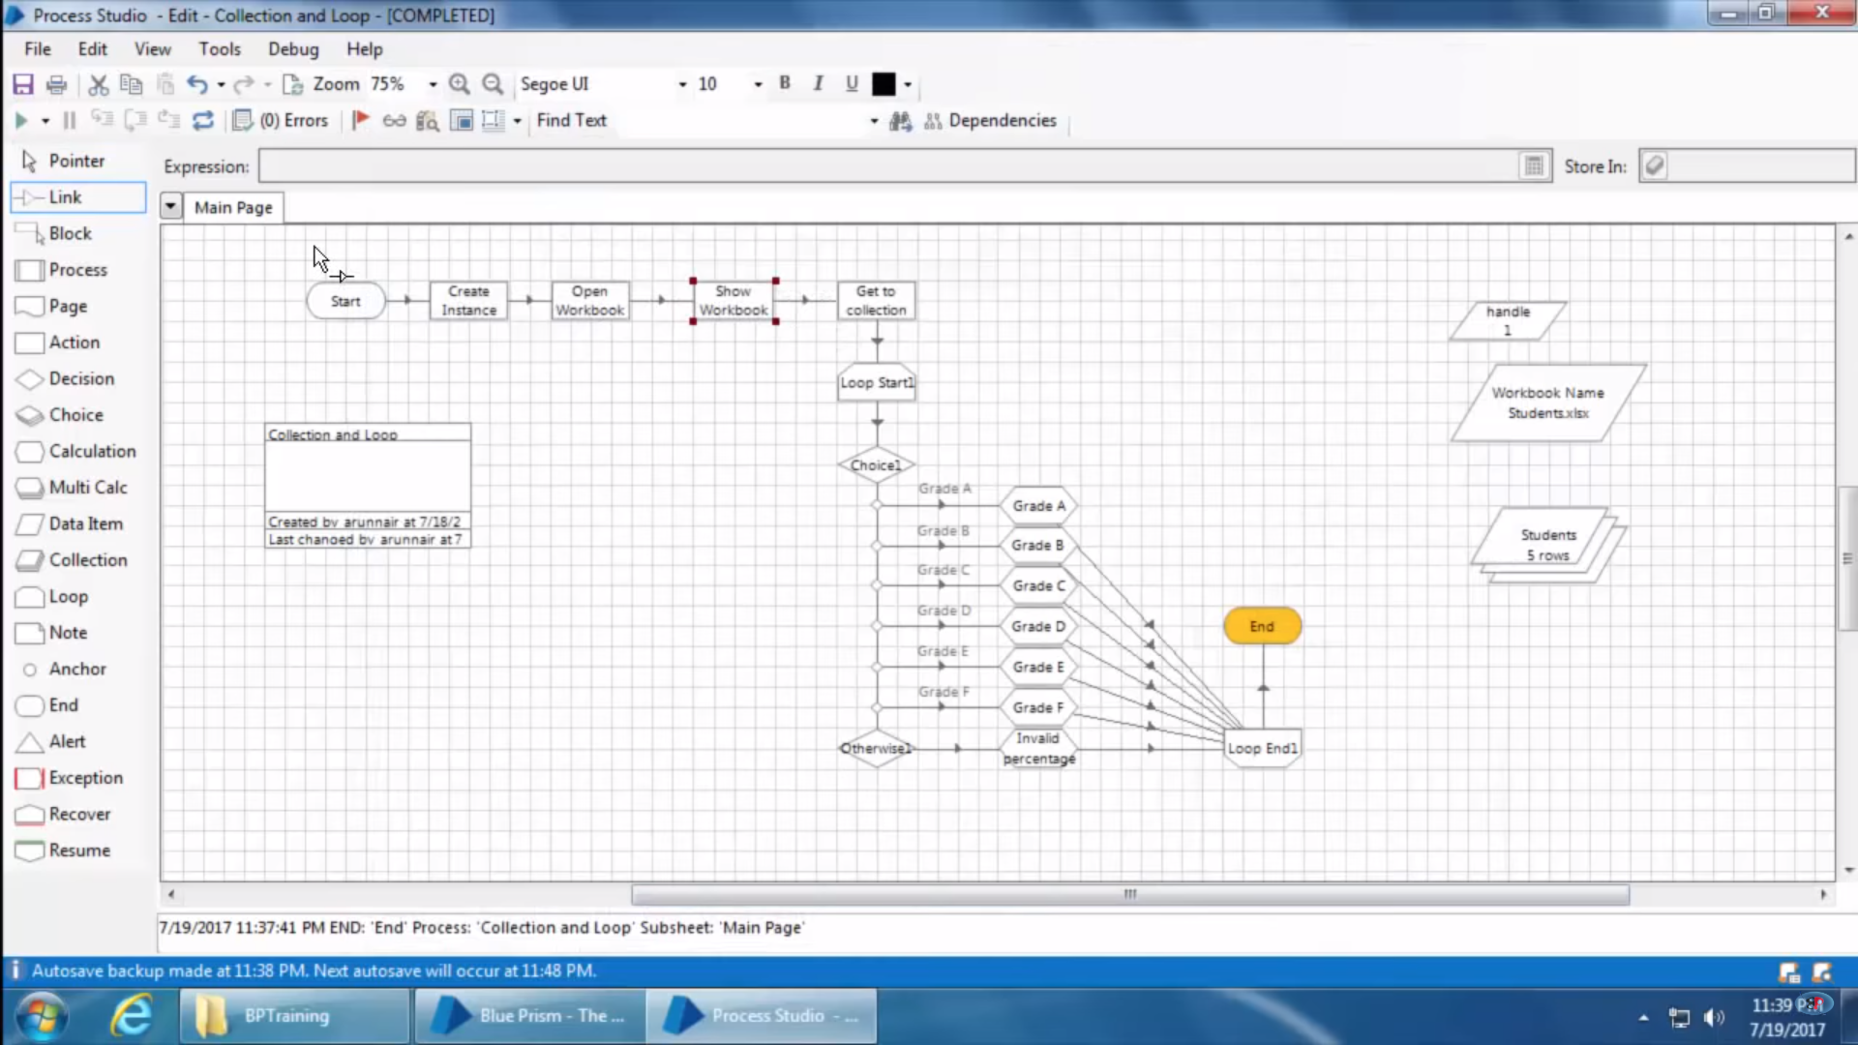

Now in order to save data to excel file we use below steps –

1. Drag an action stage and open properties –

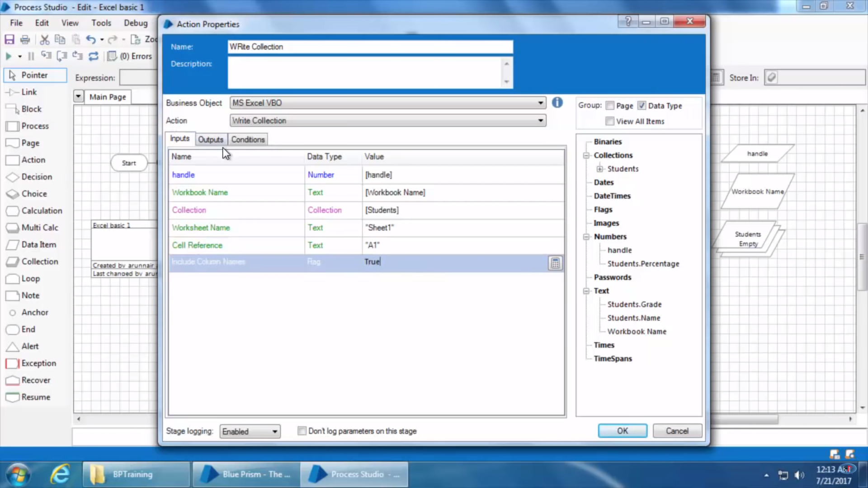

Here Cell Reference is the field that contains value of the cell from where writing will start. If We Take A1 as starting cell and make Including columns as True then it will start writing from A2 cell taking A1 as Column Field.

1. Now to save workbook we take another action stage and open it

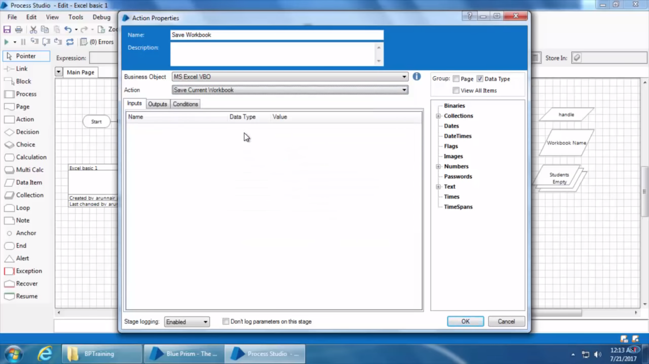

1. Similarly for closing workbook we take another action stage and select close workbook action there and the final workflow becomes something like this –

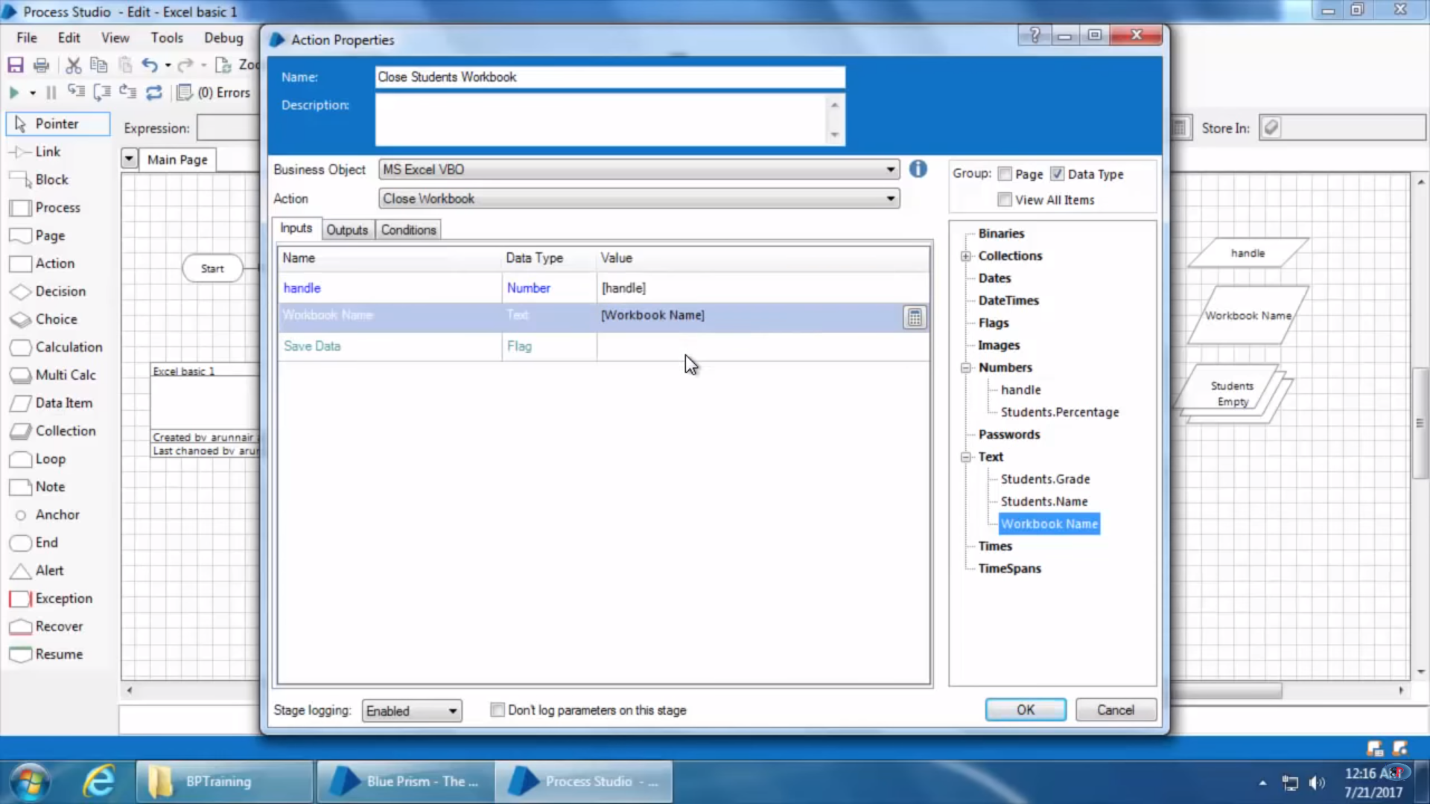

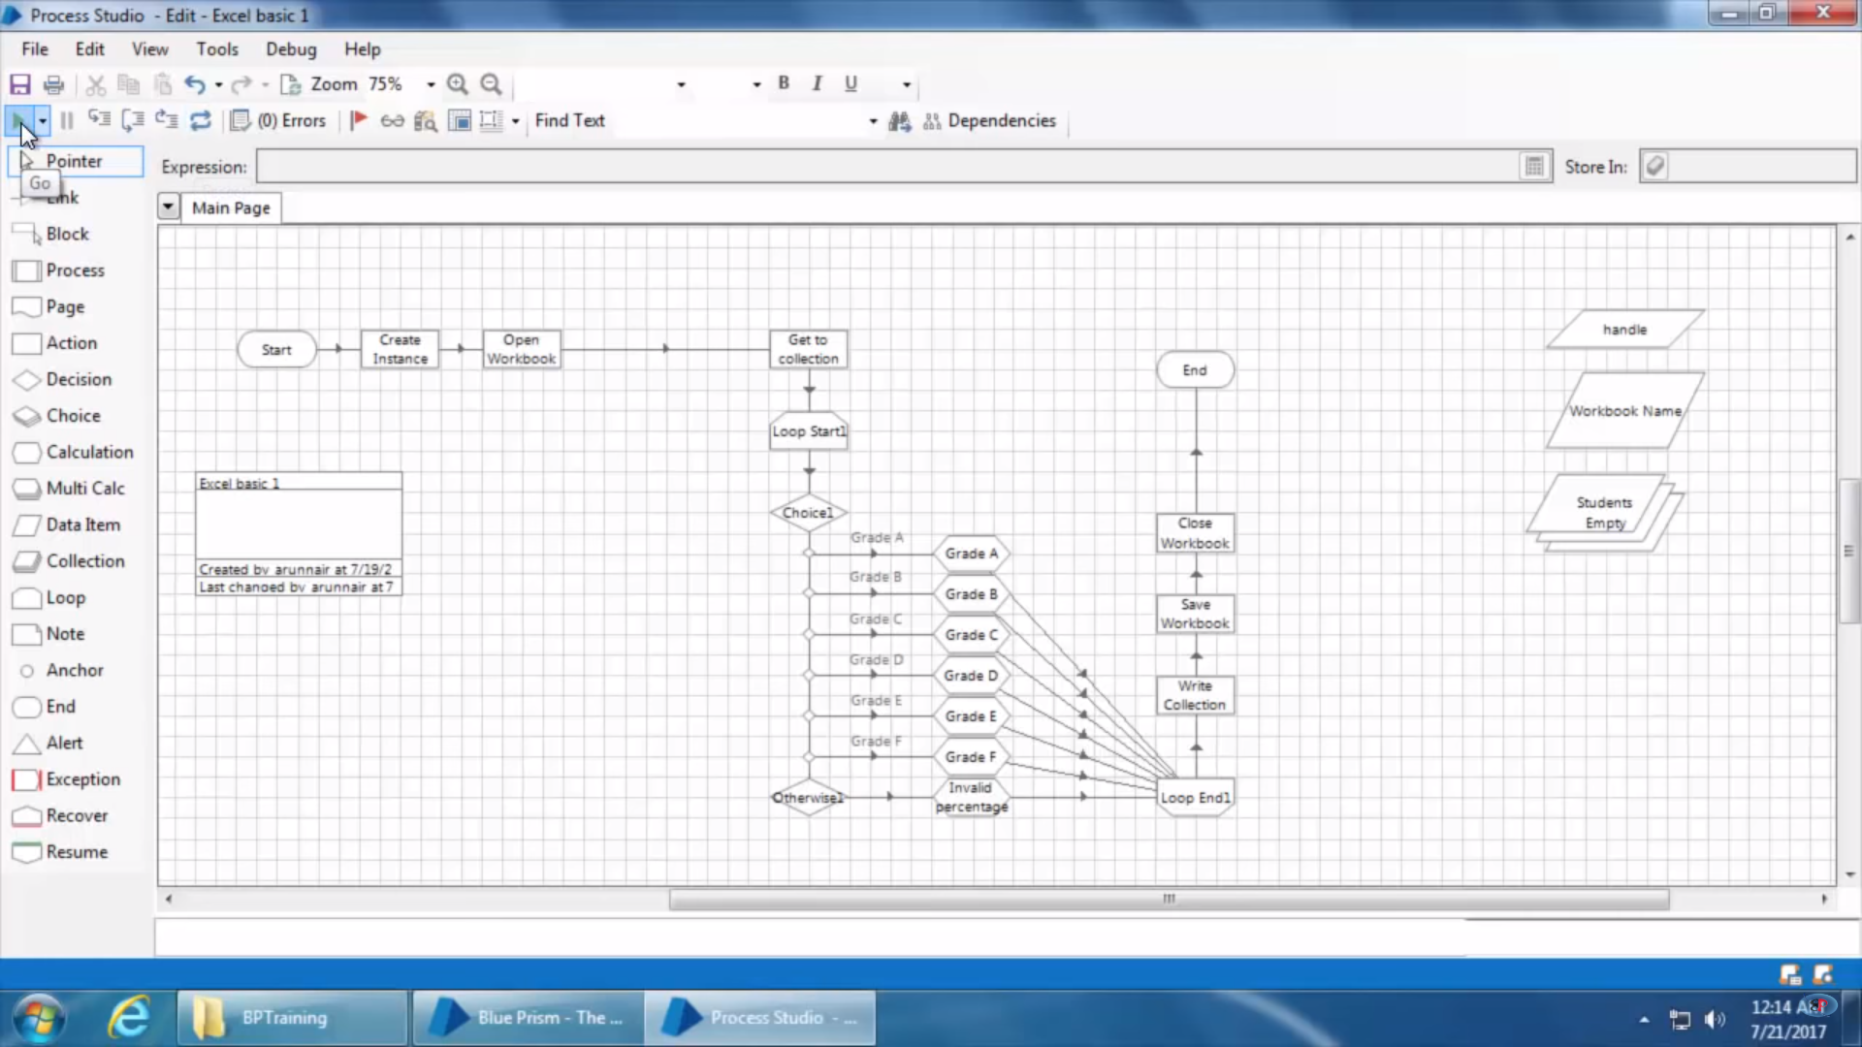

Now instead of performing the write operation in the same workbook/excel file we need to create an another file and write collection into it. Then we can do something like below –

1. Instead of creating new handle we can use the same handle created earlier at time of creating new excel instance in former stages after closing earlier excel instance so that the free handle can be used here.
   1. Output parameter here takes in workbook name which is a data set. Hence create one data set manually and assign it’s name here or click on the button at store in and it will create the dataset automatically.

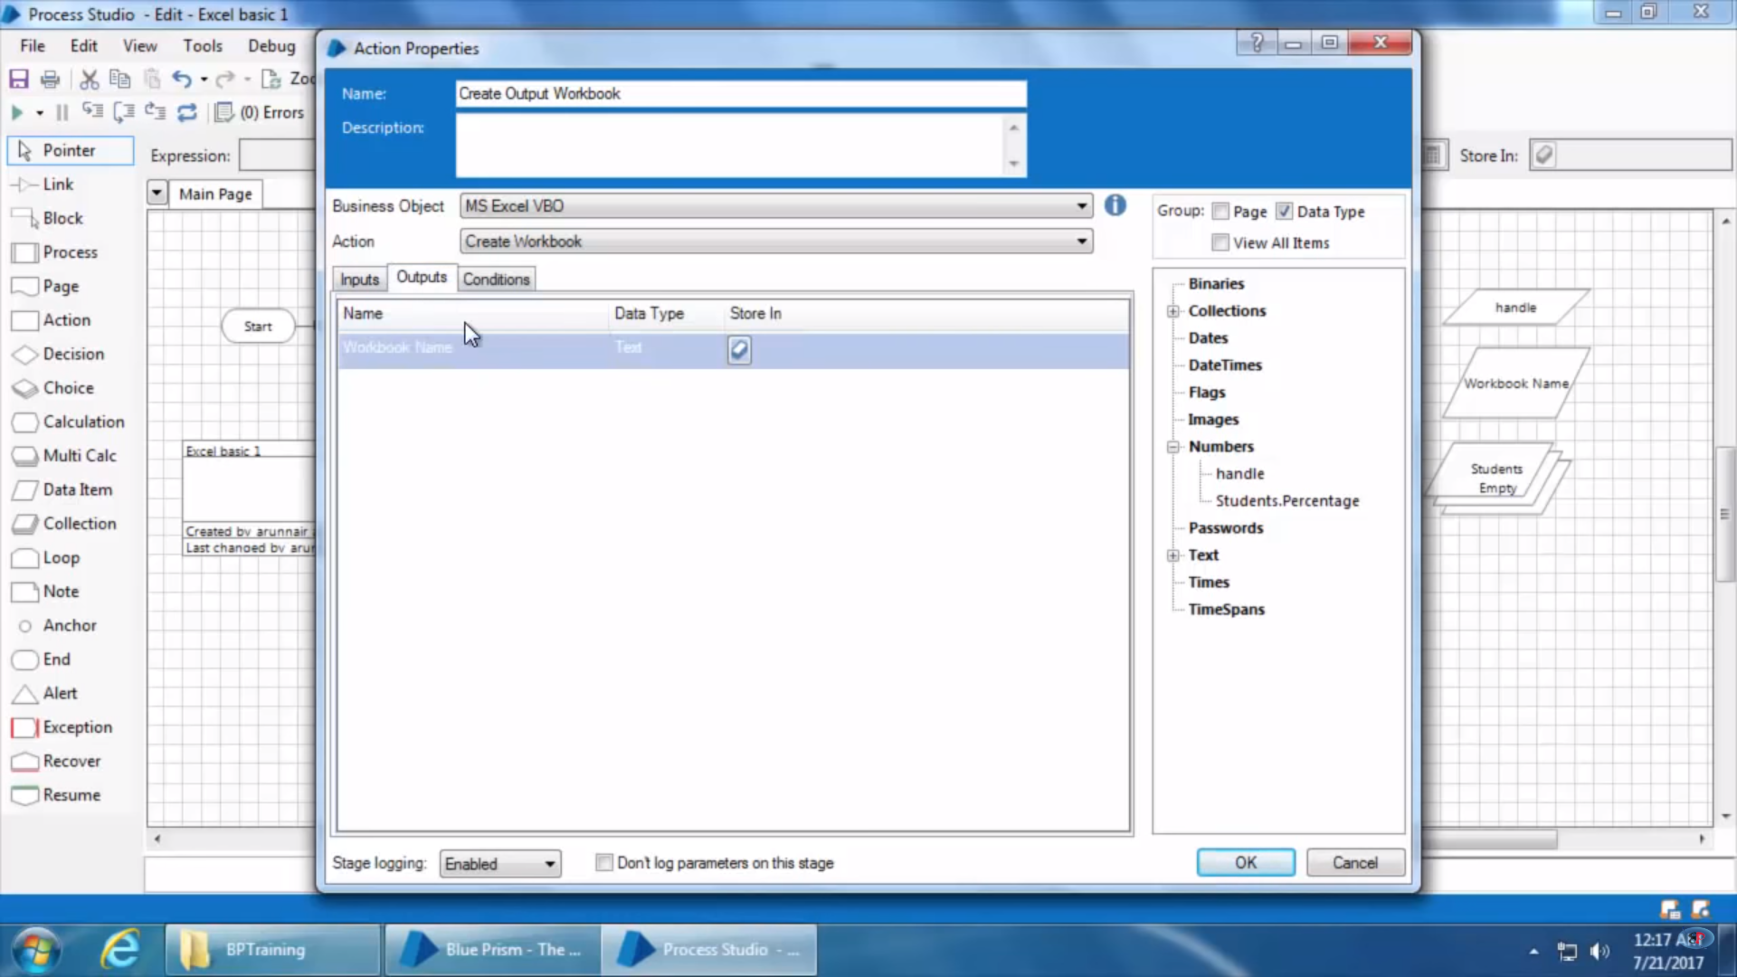

1. Drag a new action stage for writing data to workbook created and fill up following details to it –

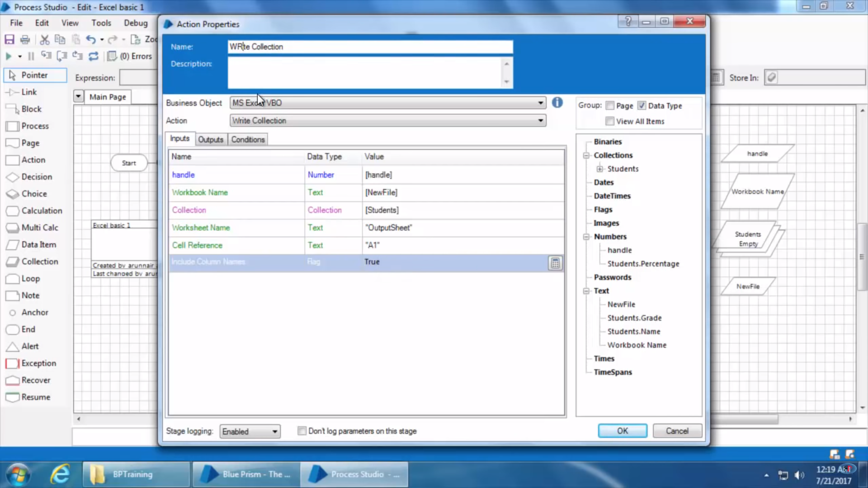

1. Drag new action stage and use that as save workbook as. Now there is a difference between save workbook and save workbook as. Save Workbook will save workbook with default name however save workbook as will save workbook with name given in it properties so in order to save workbook with custom name use save workbook as.

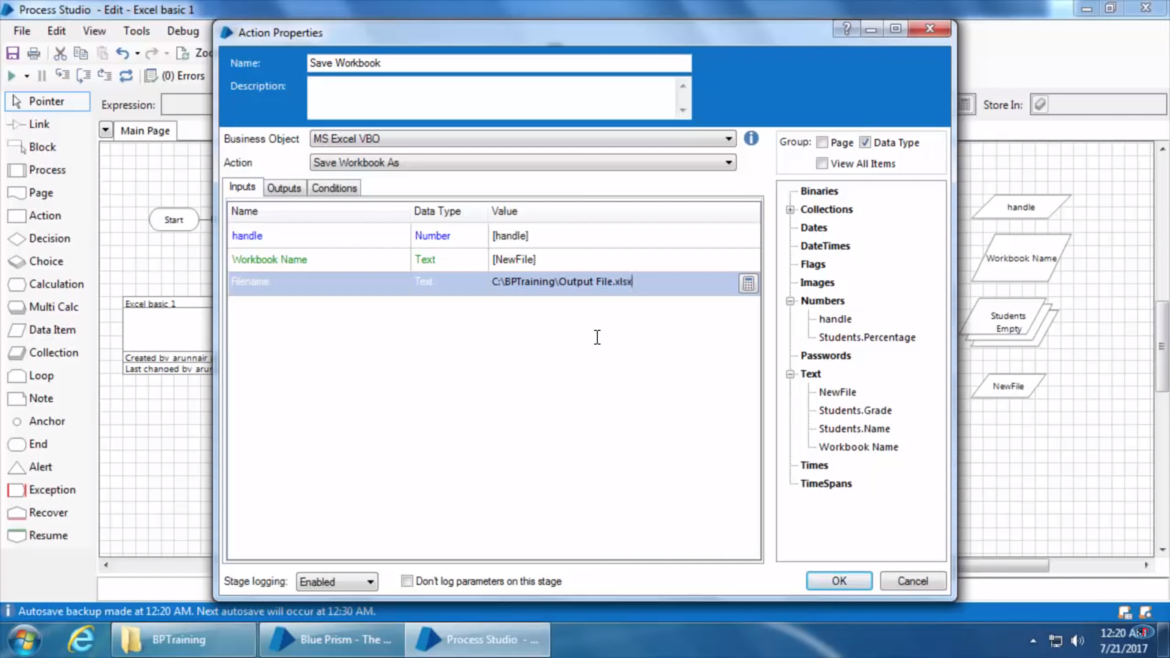

It’s output parameter takes in new workbook name dataset, hence create a new dataset and assign to it

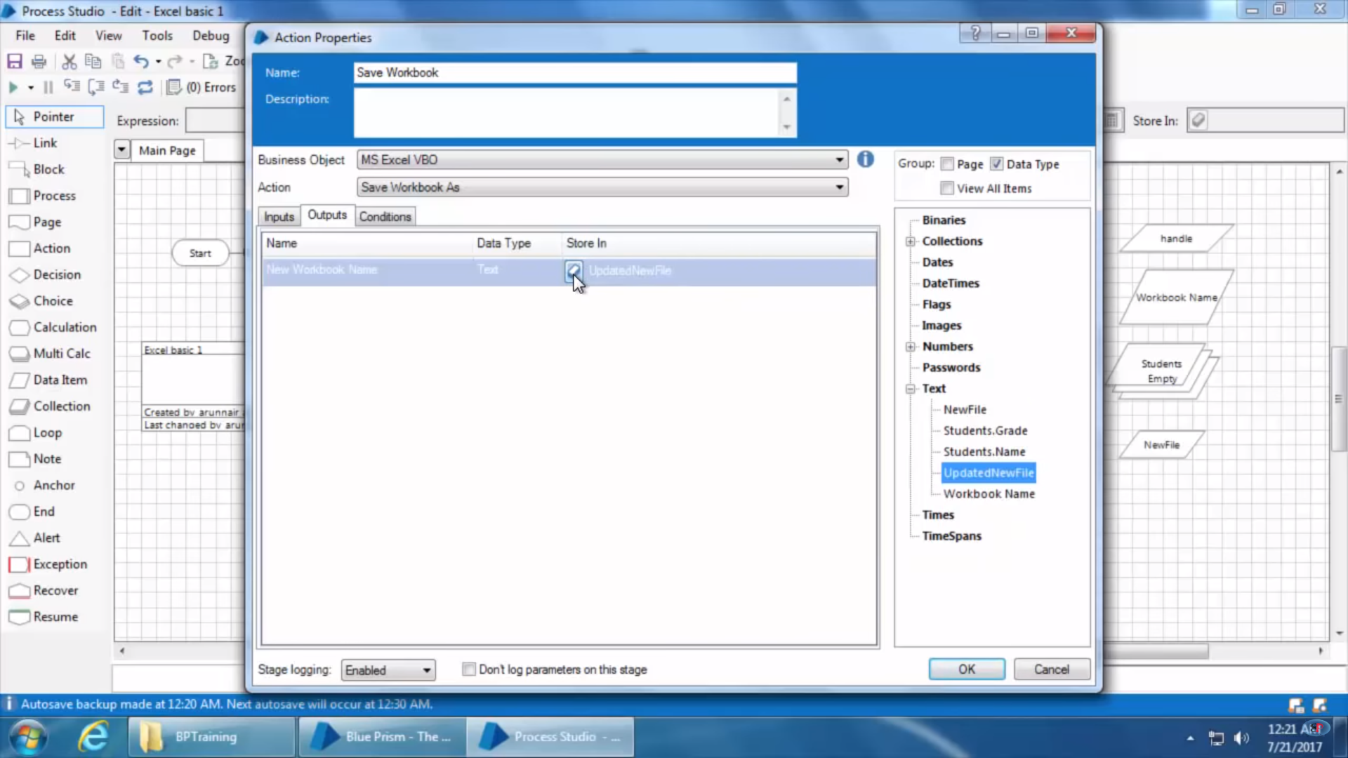

1. The complete final workflow would be like as below –

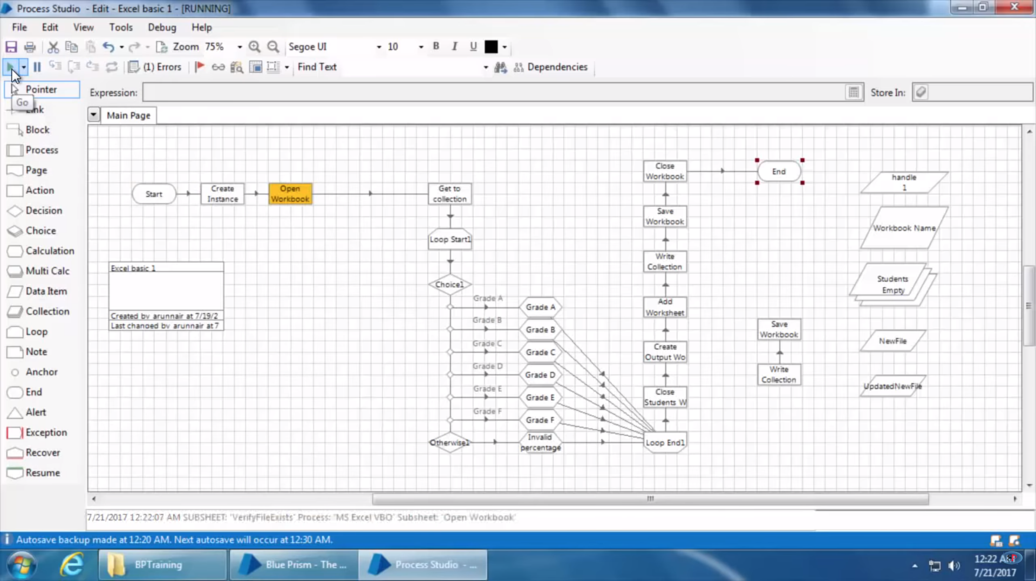

1. The file has been created with the name specified –

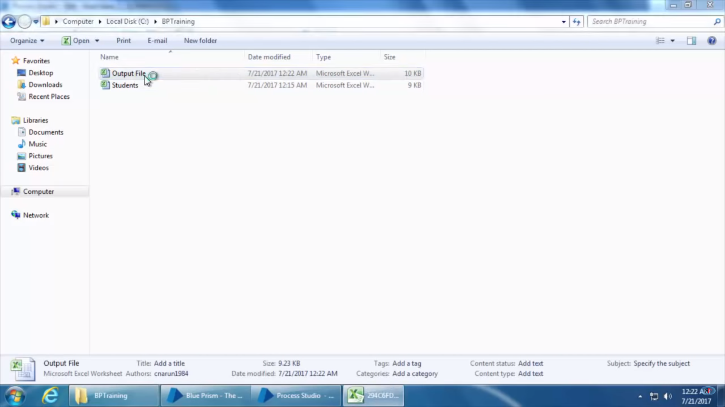

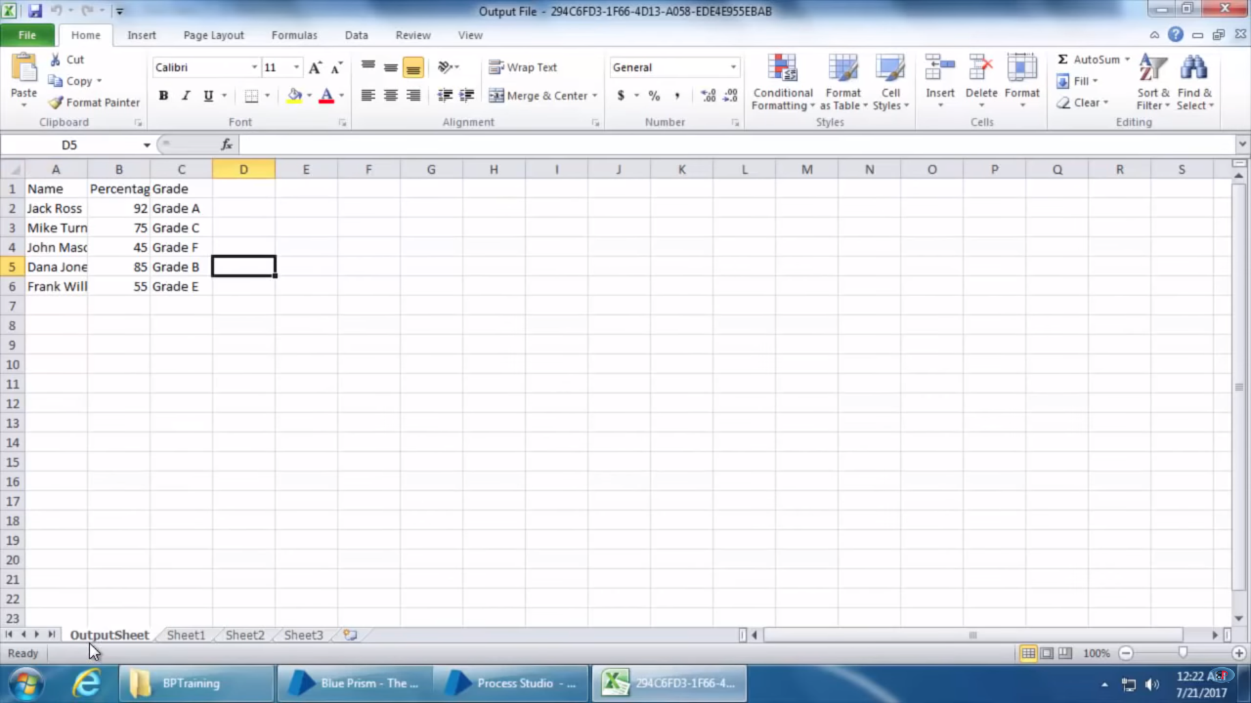

# Importing VBOs (Visual Business Objects) in Blue Prism

In the above example of Excel Automation we shown how to use MSExcelVBO but we didn’t show how this ms excel vbo is here in the action stage of blueprism.

VBO are created using object studio in blueprism. BluePrism provide set of most commonly used VBO that user can directly use without explicitly creating them like excel, word, active directory, sql etc. But these vbo are not shown in action stage unless these ae imported. Now to import them use below steps –

1. Open main screen and go to file and import-

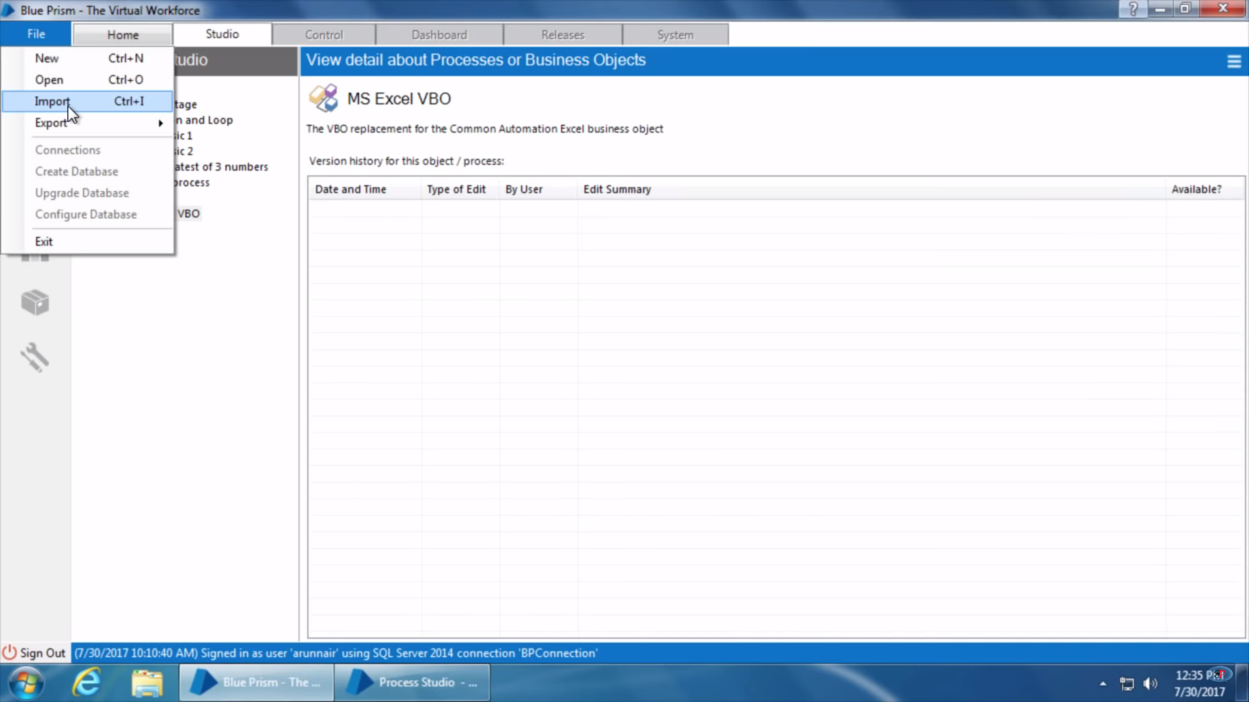

1. Click on Browse on opened screen and go to C:\ProgramFiles\BluePrism and there you will find the list of all VBO comes already with blue prism installation-

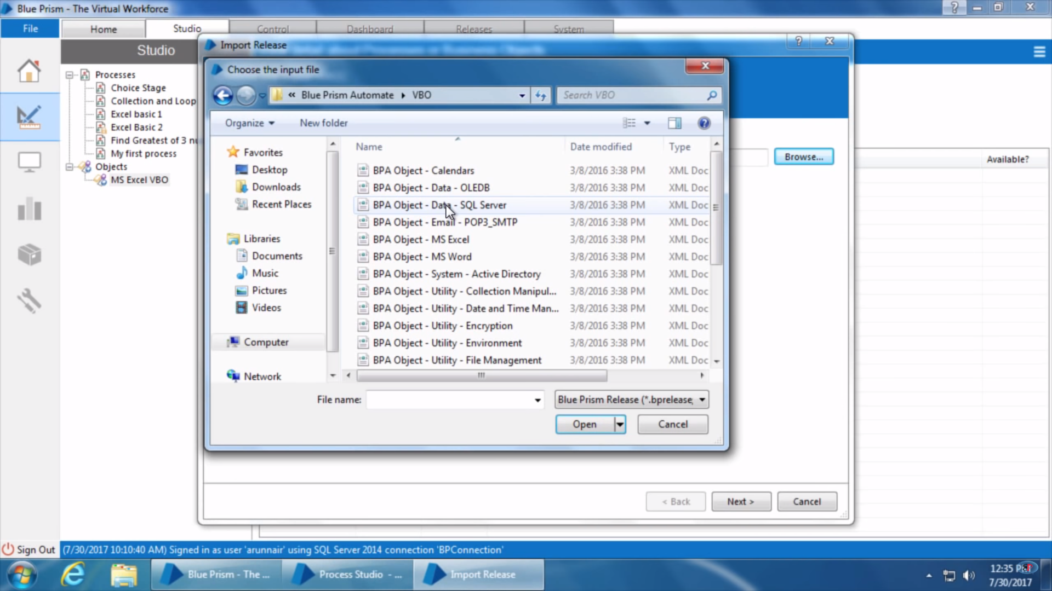

1. Select MS Word VBO-

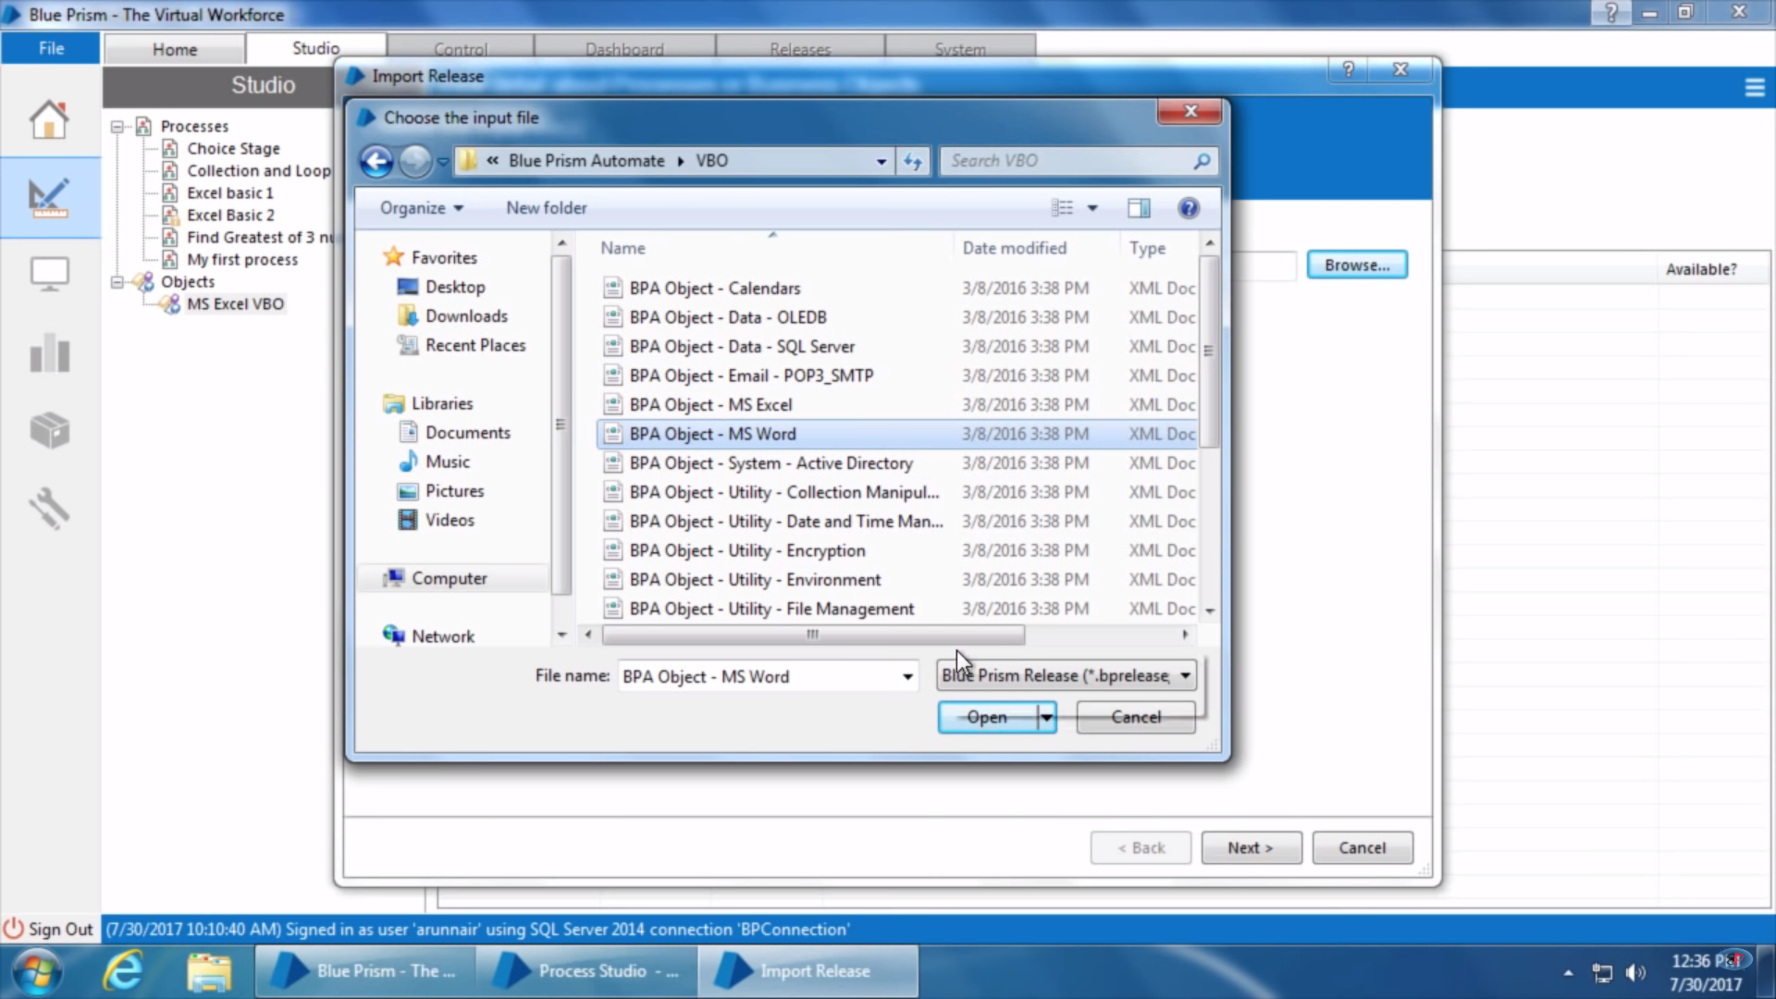

Open it and and click next

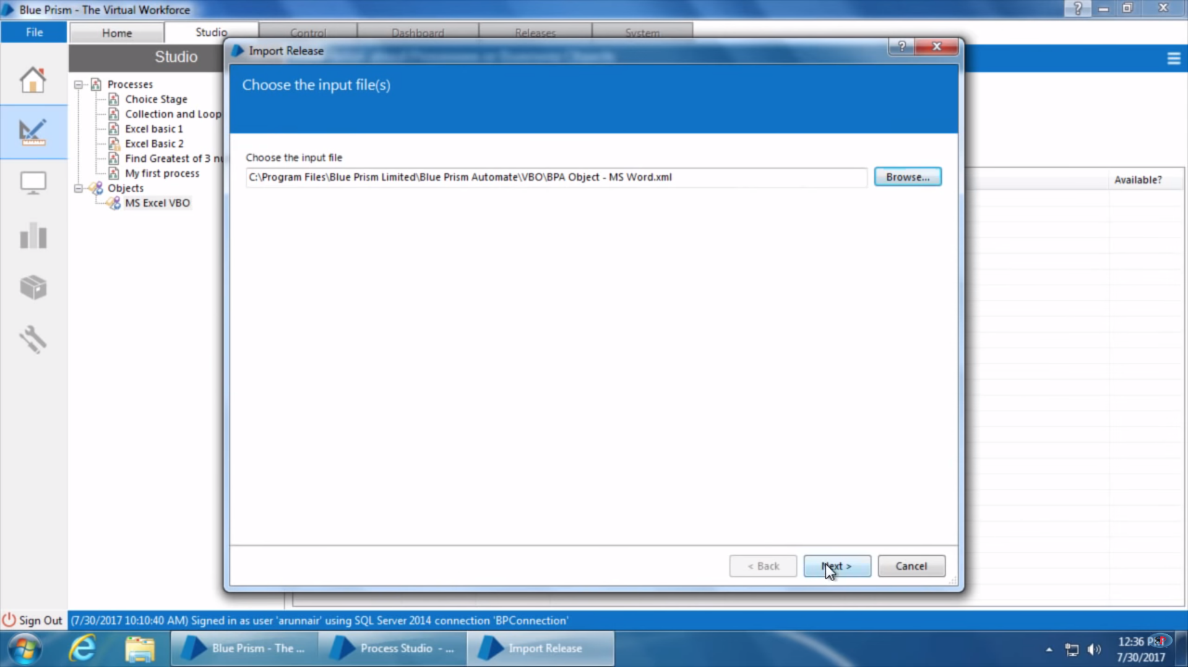

1. The VBO has been added to the object studio now –

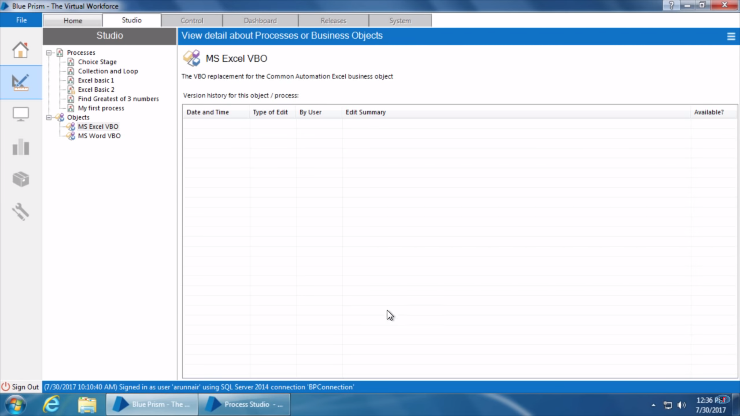

1. Now close blueprism process studio once and open again, drag a new action stage and there you will be able to find the imported new VBO-

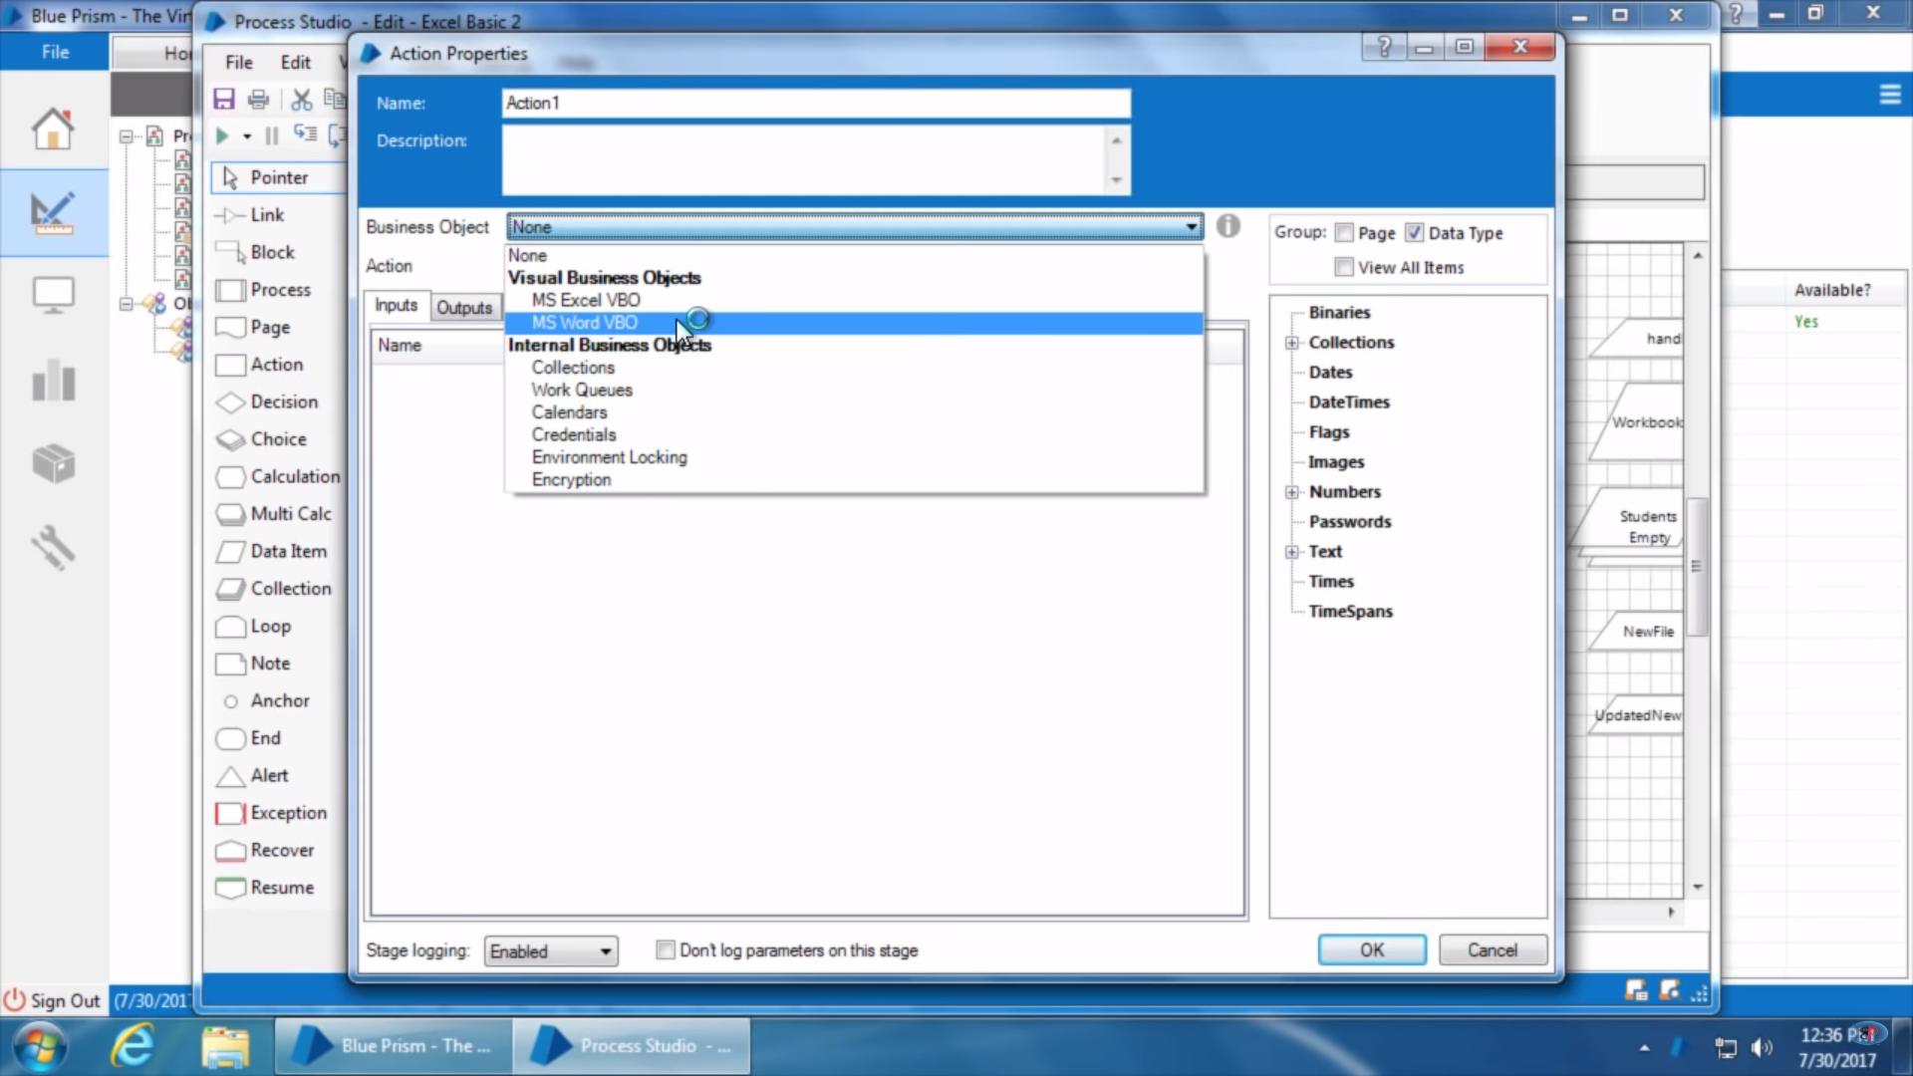

Selecting the VBO in Business Objects would show all of it’s available functions in action field –

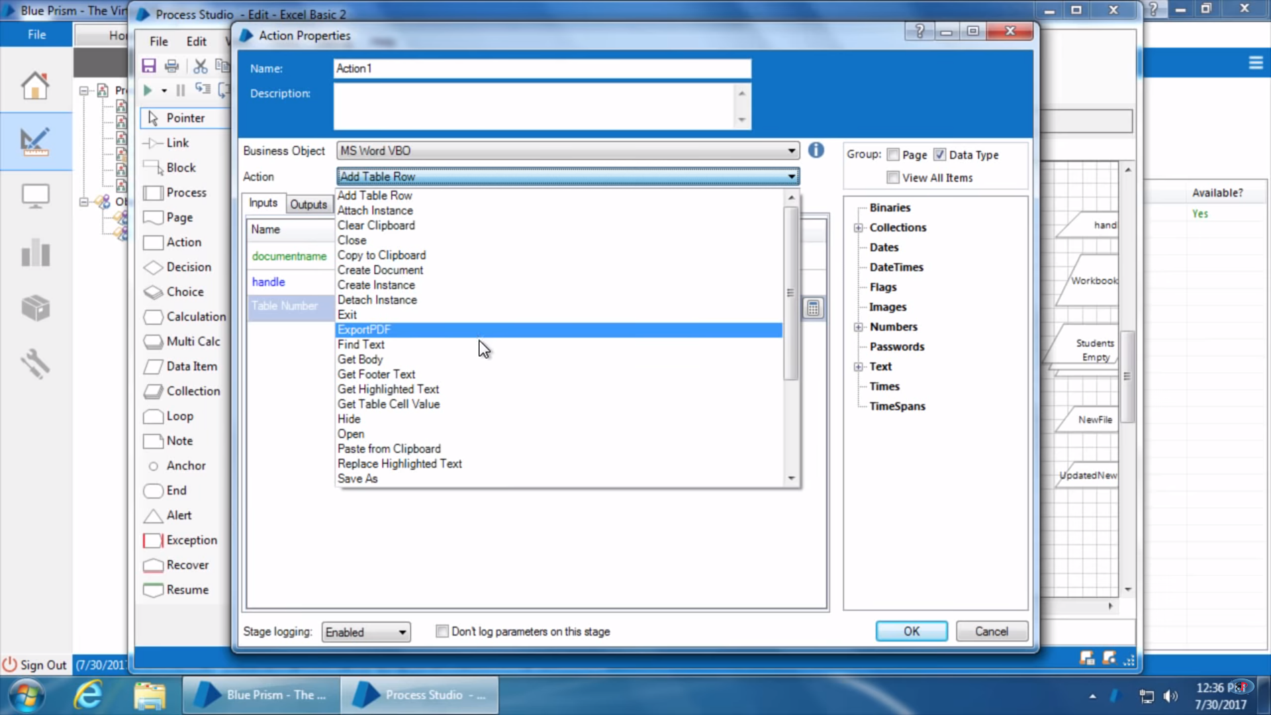

# Creating VBO for Windows applications

Create VBO as using below –

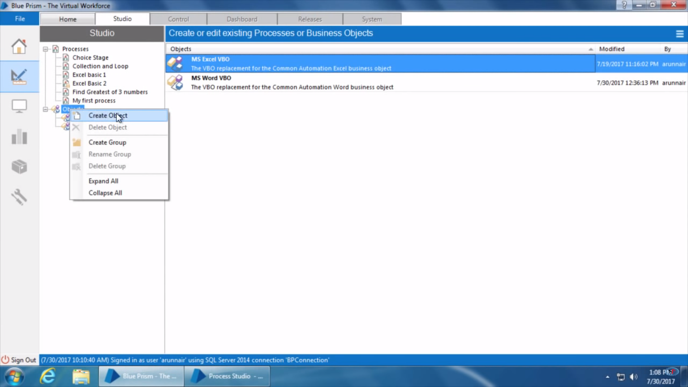

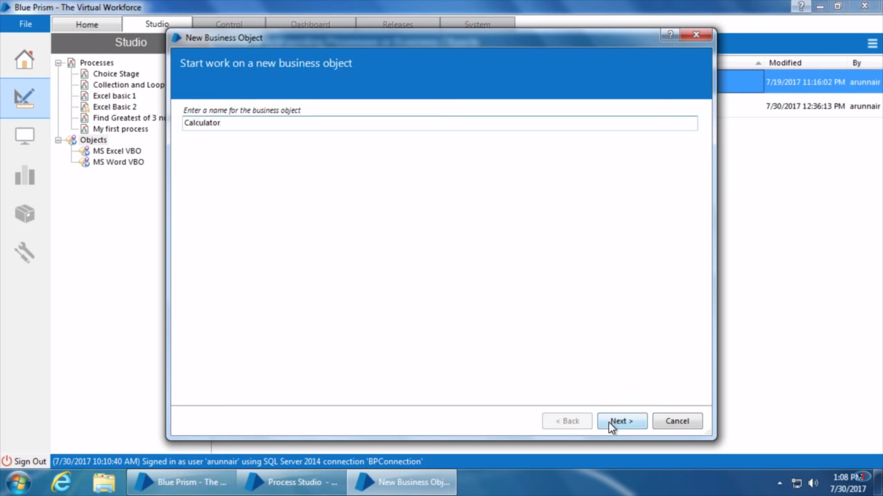

Double click on the VBO Object created in Object studio and it will open object studio.

Now let’s compare difference between Object and Process Studio-

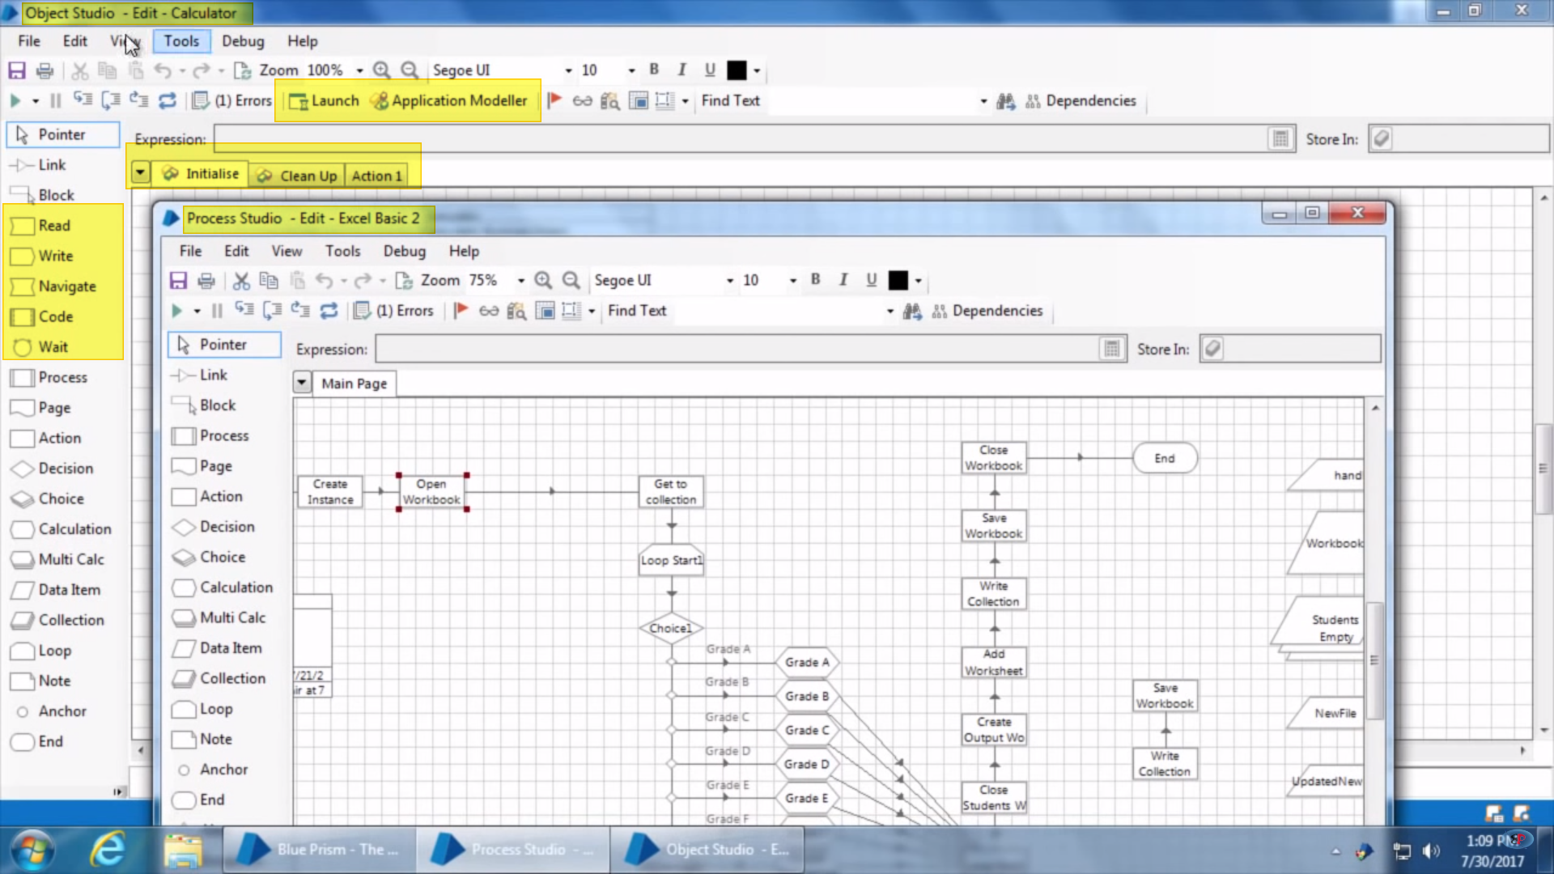

* Object studio has five extra stages – Read, Write, Navigate, Code, Wait.
* Object studio has two extra buttons on toolbar – Launch and Application Modular.
* When process studio is launched it has only one tab initially that is main page whereas when launched Object studio it has three tabs initially that is – Initialize, Clean up, Action 1.

Now these tabs are called pages in blue-prism terminology. (pages are also used to logically divide business process in blue prism to smaller parts). Something like below –

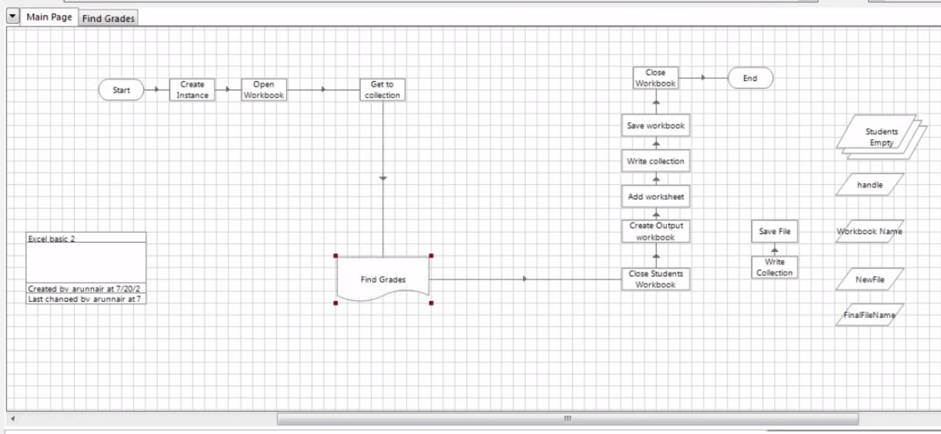

As the finding grades part it moved to another tab (page) and that page reference (Page Stage) is been used in main page.

In Object studio pages are created to use individual actions. Each page created in object studio will appear as an individual action in action stage.

Now if we open a ms excel vbo we can see that there are multiple pages and each page acts as a individual action-

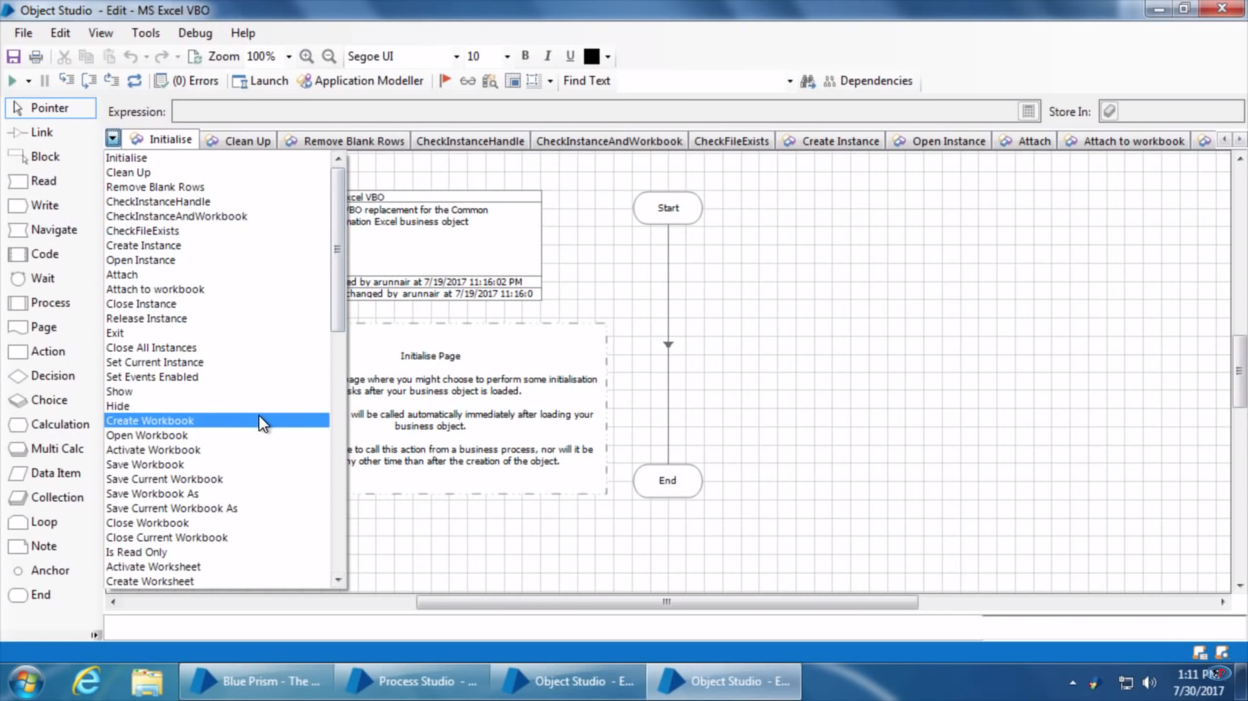

All of these pages appear as action in Action state –

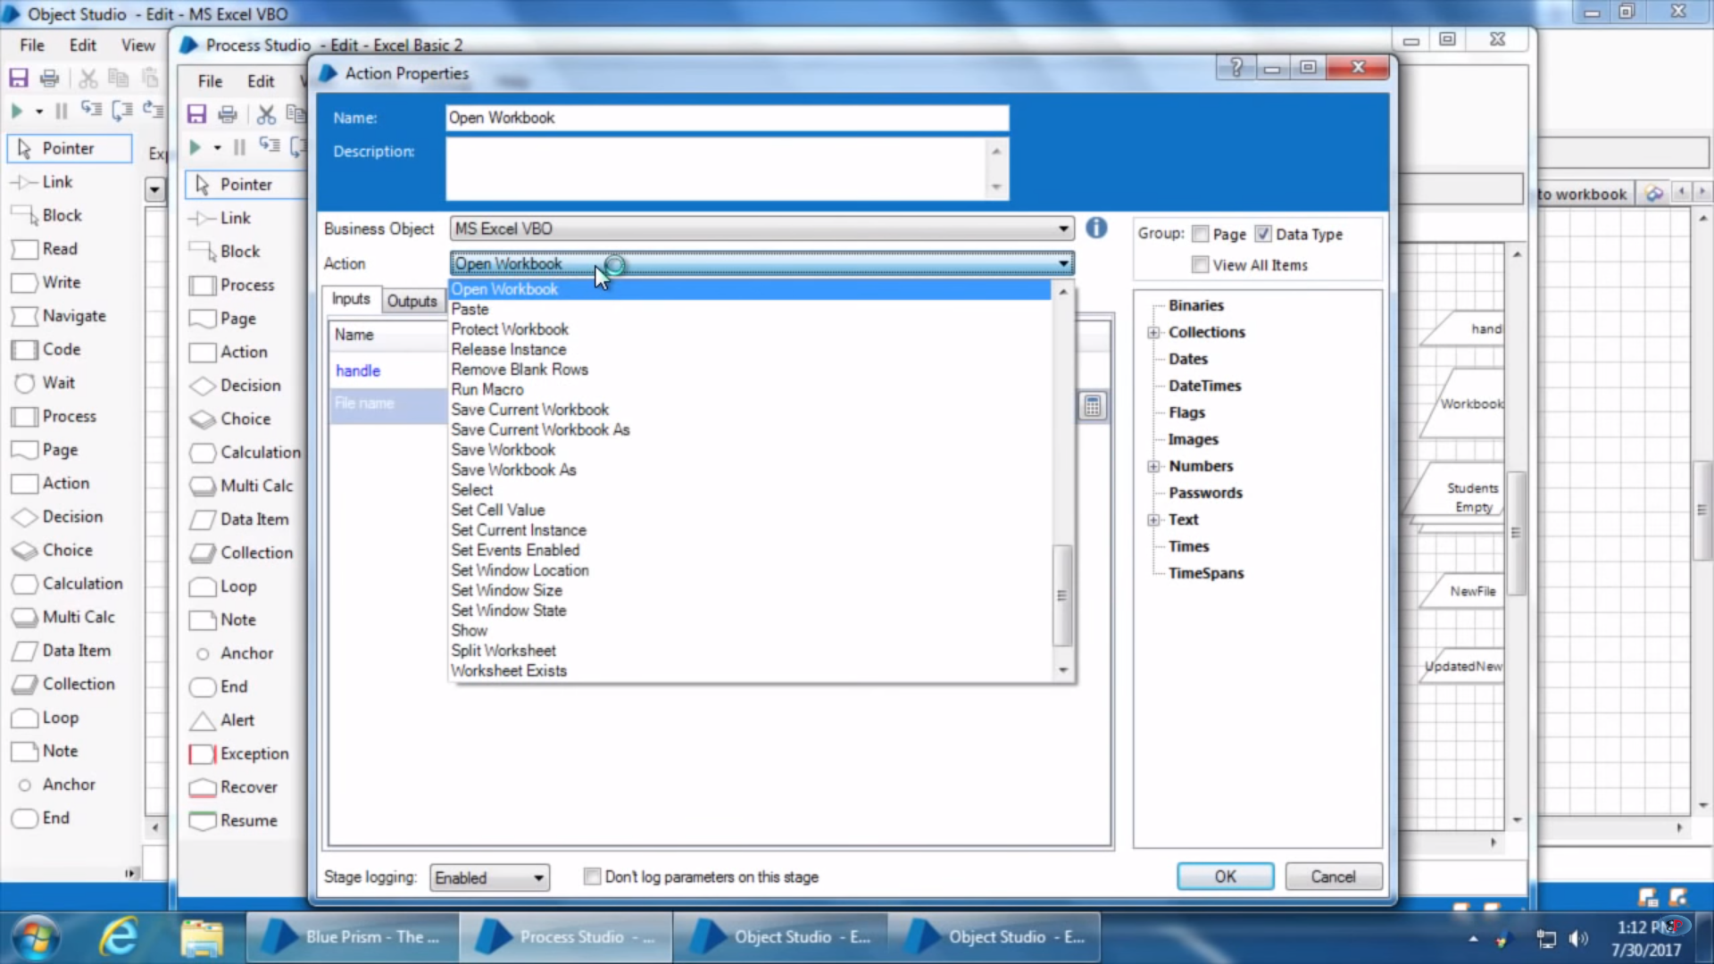

Now, moving forward for creating new VBO-

As we are creating a Calculator VBO so we first need to tell Blue-Prism that how to interact with calculator and for that application model need to be created using Application Modular.

1. Now click on Application Modular button –

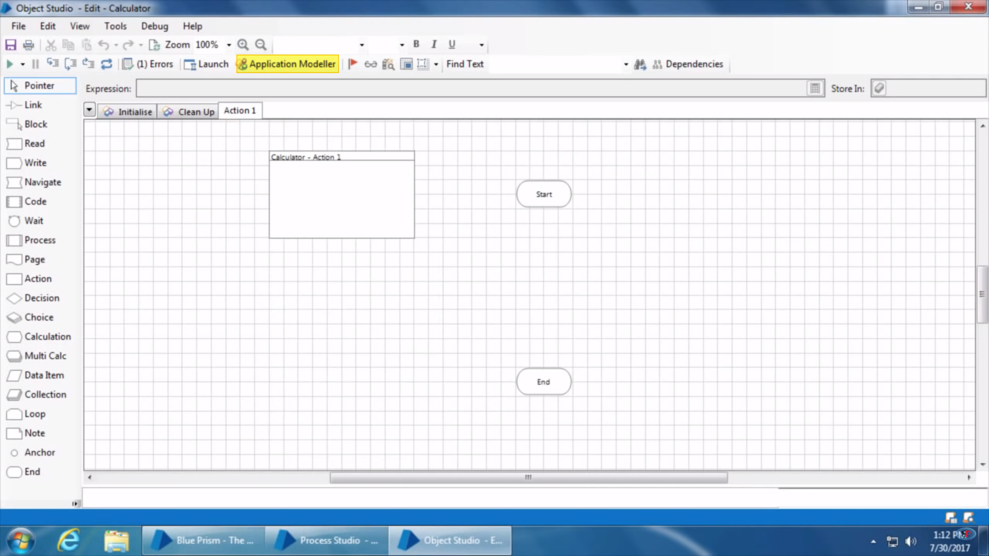

1. It opens up Application Modular Dialog –

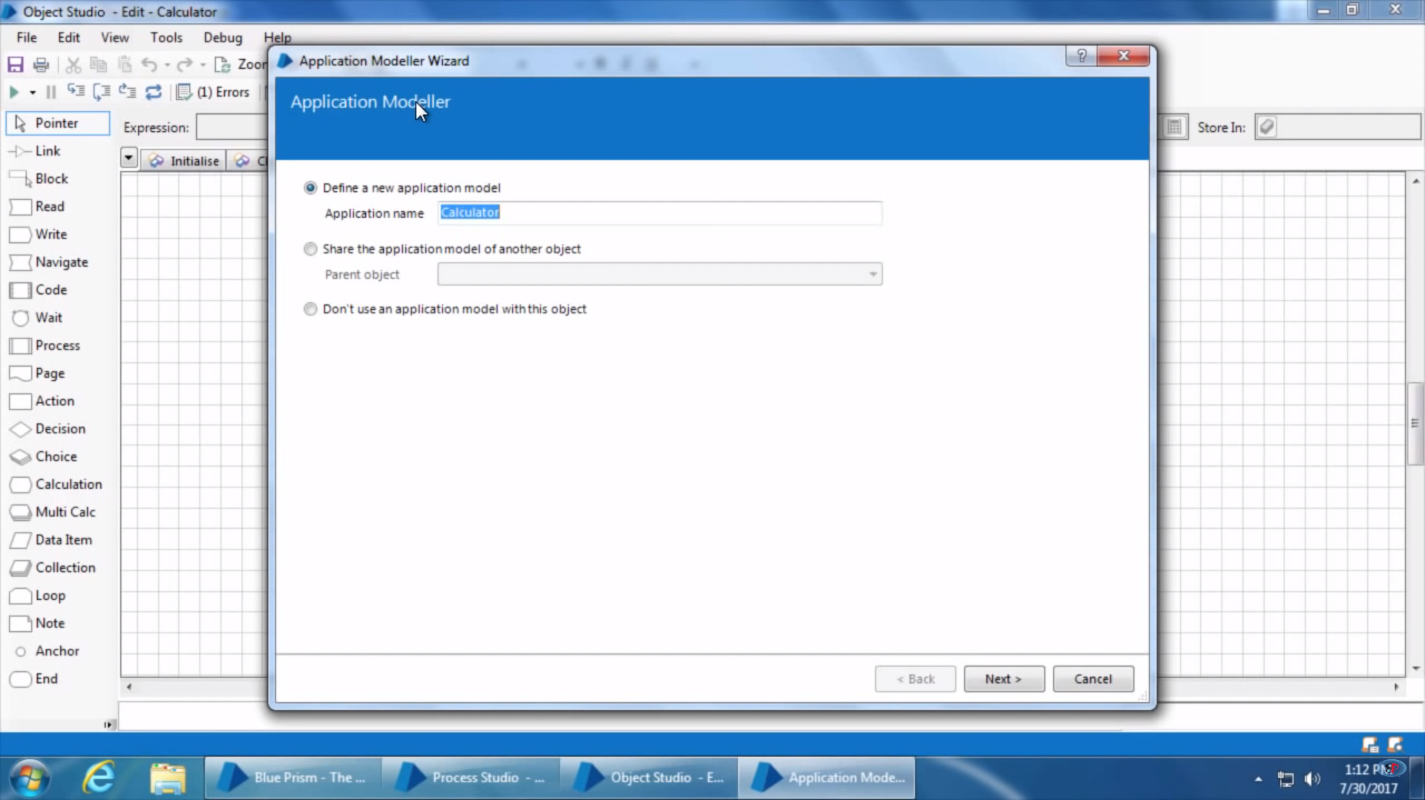

1. Give name of the application VBO and click next – Select type of application.

Blue Prism works with four kind of applications – as given below

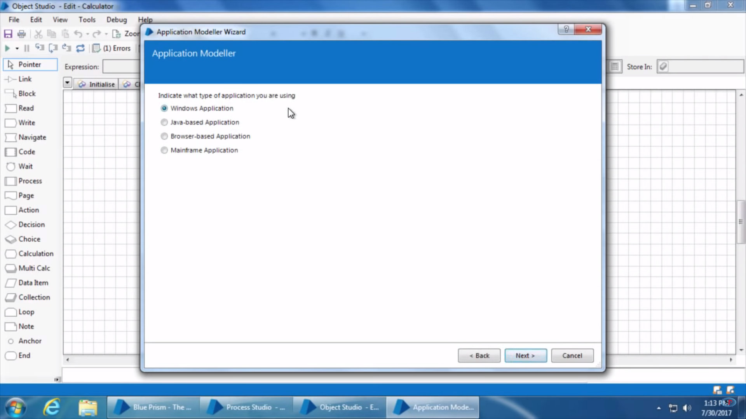

1. Click next – Select if the application is already running and you want to attach to that running instance or else if you want to open a fresh new instance of the application.

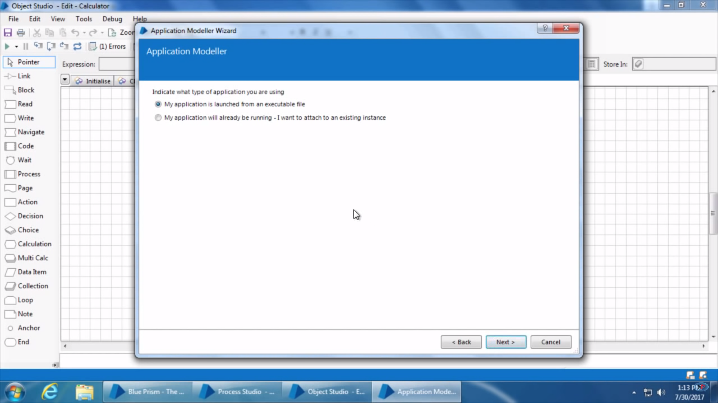

1. Selecting first to open a new instance and click next. Now give the path of the application exe.

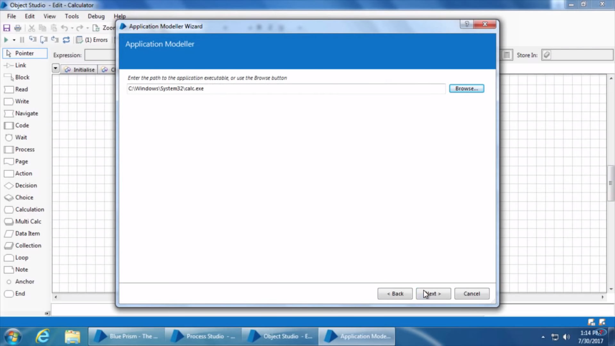

1. Click Next on upcoming dialogs choosing defaults one and click the below dialog gets open up

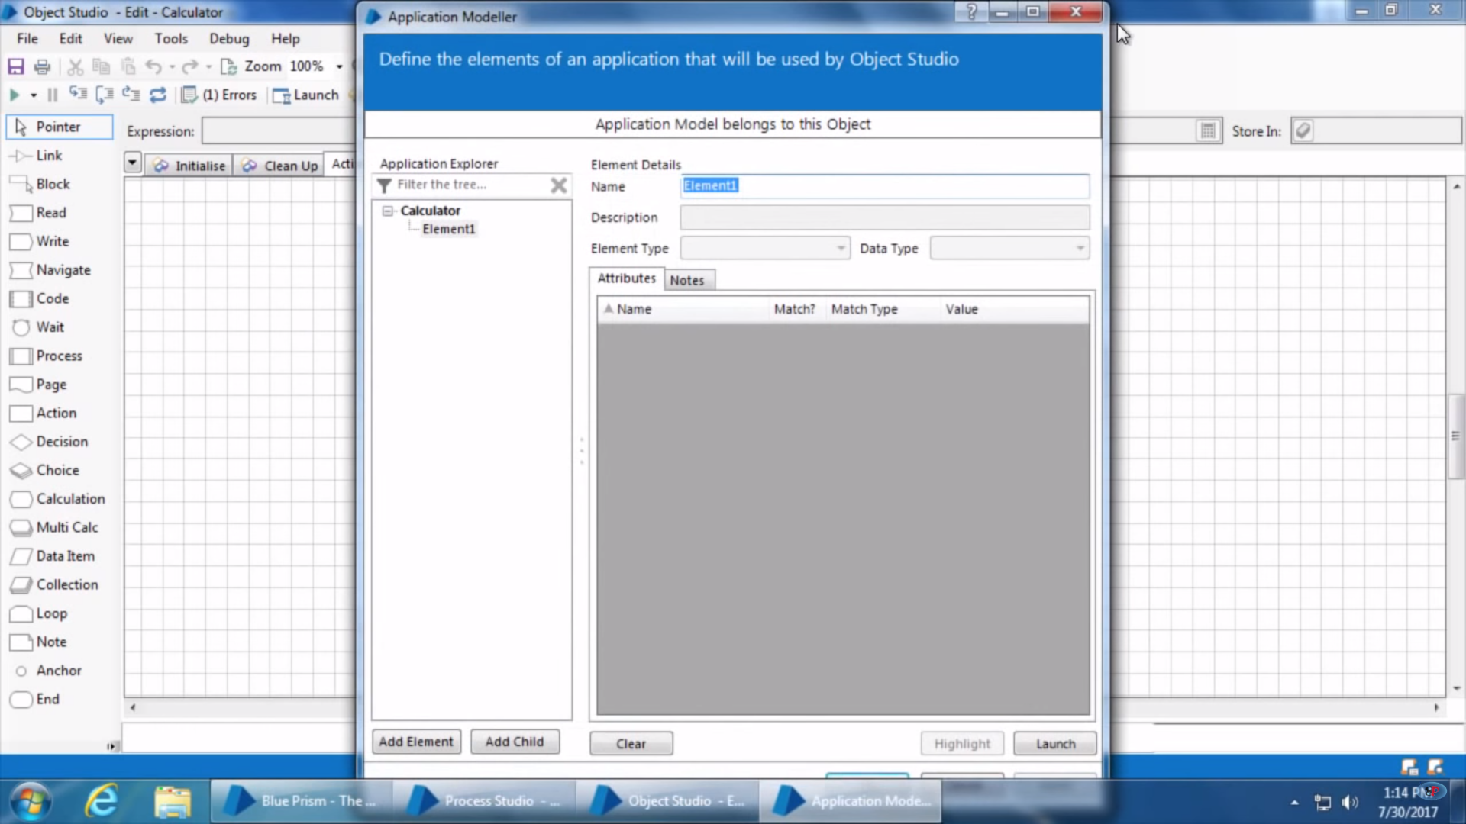

This dialog is divided into two sections. On left hand side it will list all the elements of the application. And on the right hand side it will display the attributes of the elements.

**Elements** - are the buttons/text/fields and other controls on the applications. All these elements appear as a tree in elements section and root of the tree is the application itself. Clicking on application opens up app properties.

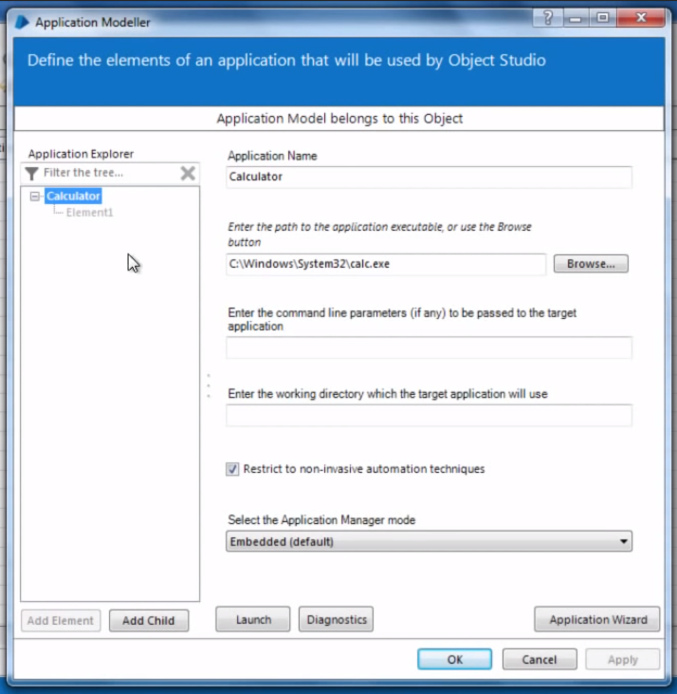

1. Let’s move further and create first action to launch application. Drag and drop navigate stage to the canvas. Navigate stage is used for – Navigation Actions like – Click button/Open Window/Close Window/Launch App/Send Key Strokes etc. Now open navigation stage and it opens up following dialog-

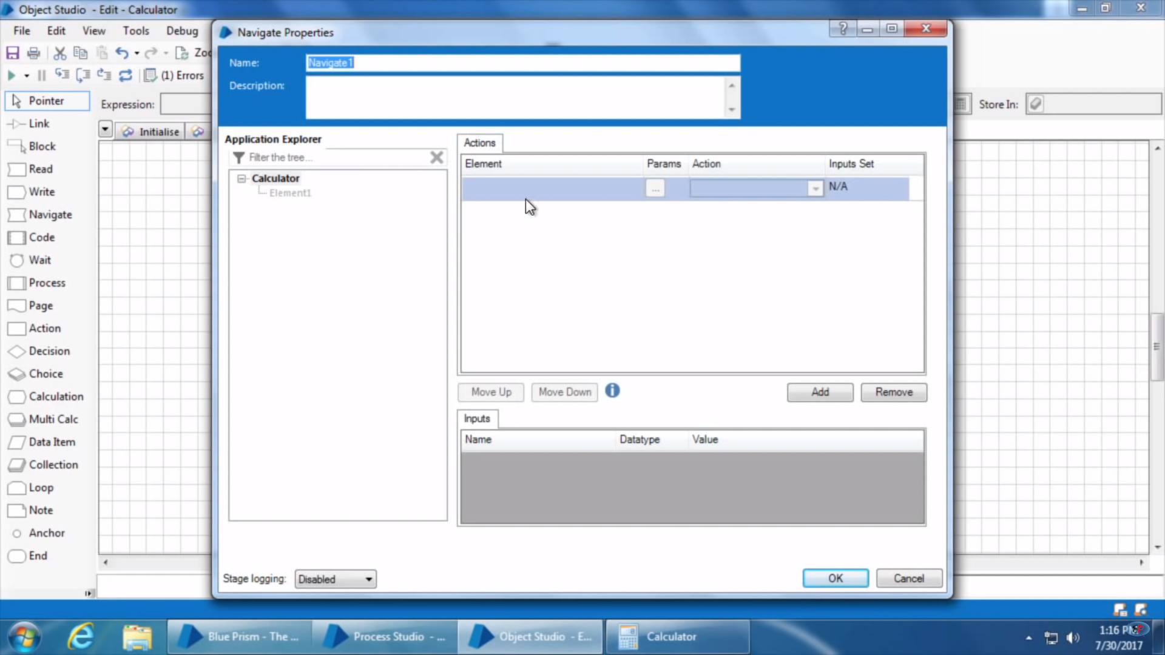

1. Now drag and drop calculate element from left to right(Action) –

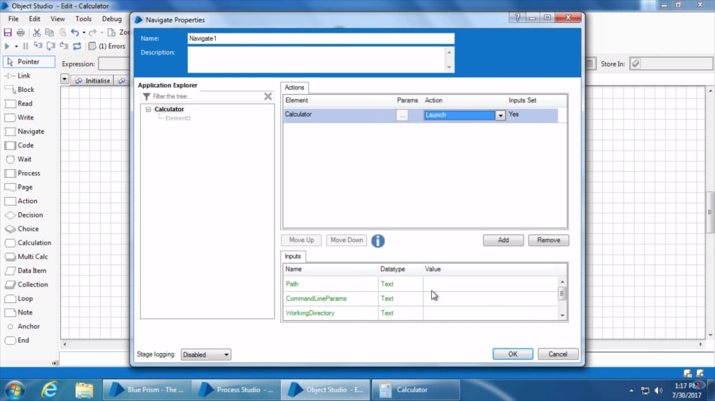

1. There are different actions based on the element type so choose appropriate one as in above case we are choosing to launch calculate.

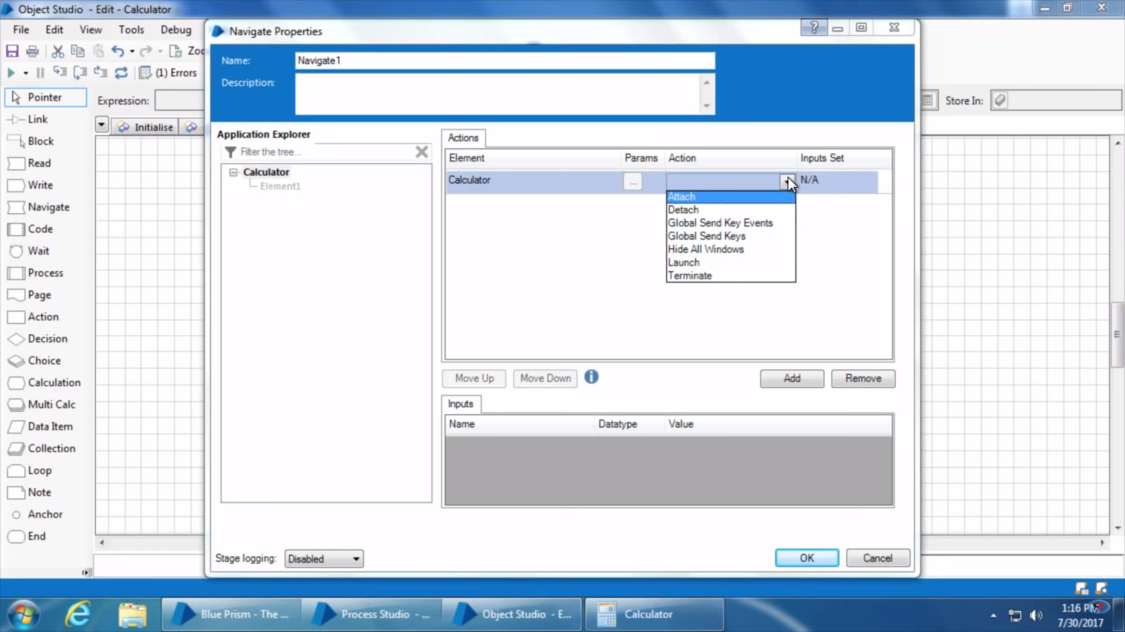

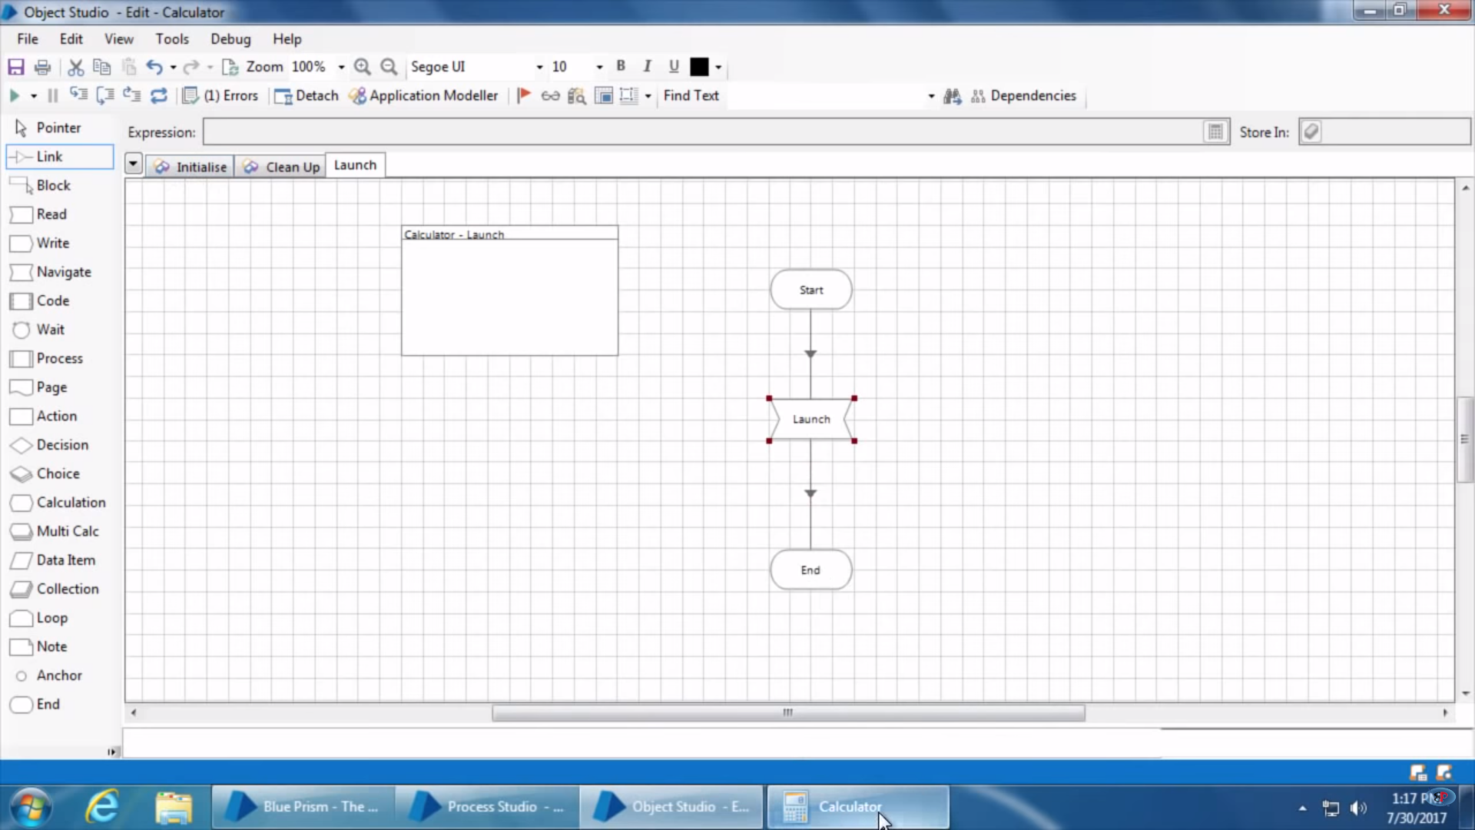

Now in order to use this launch action in process studio we need to publish this action as given below –

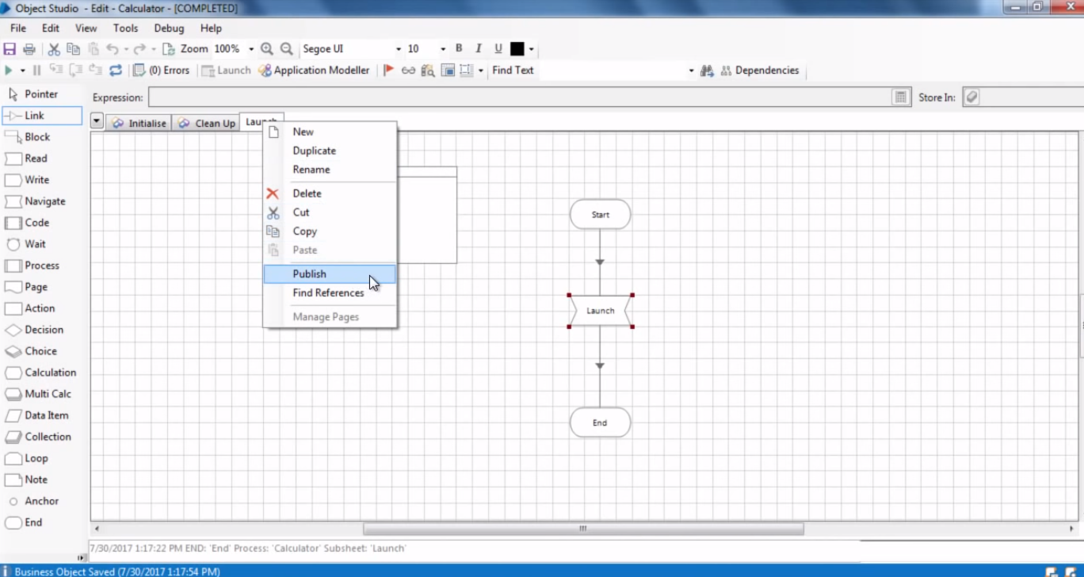

Once the action is published and VBO is saved you can use that in action stage, in process studio. This is primarily used in case if the any action need to use another inherent action which is not published.

1. Capture buttons of calculator-

In order to spy on buttons of calculator that needs to be opened using blue prism application modular only, in case if it’s not opened using that then blue prism will not be able to spy on the buttons of calculator.

Now click on Element on left side as given in below image

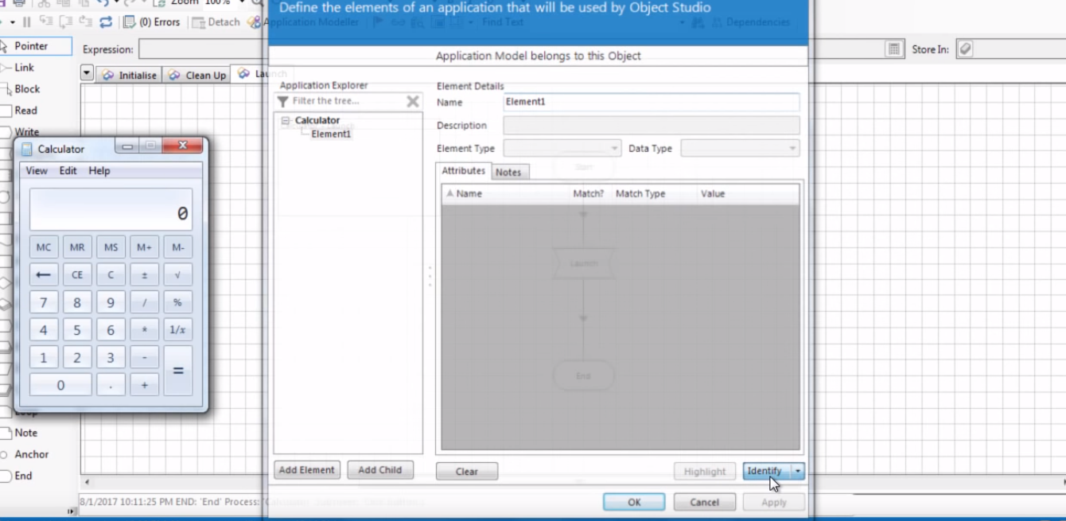

And click on Identify Button. After clicking this button blue prism goes into spymode.

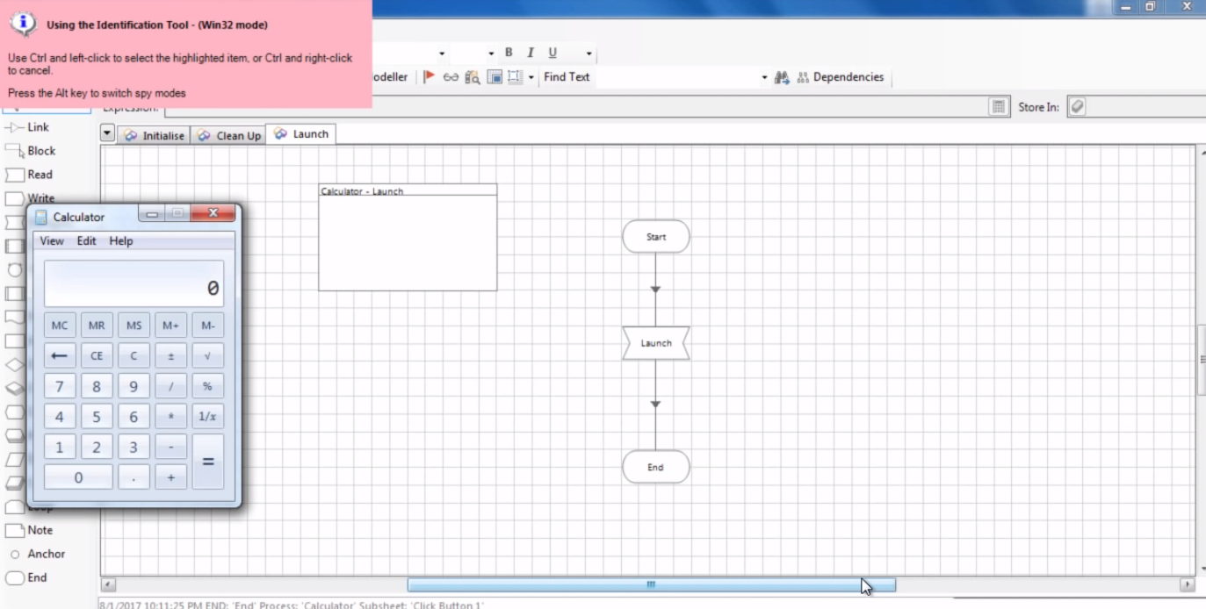

There are different types of spymodes in blueprism and the one can switch between these modes using ALT key.

**Win32 Mode, Accessibility Mode, Region mode**

For windows application win32mode will work fine.

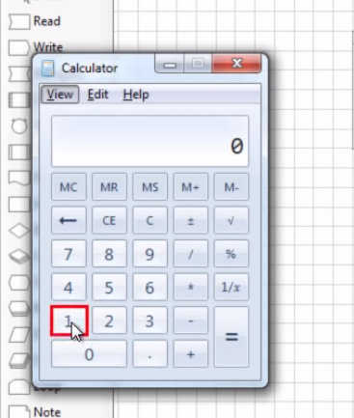 Hover over the button verify it is highlighted and press ctrl key and do left click.

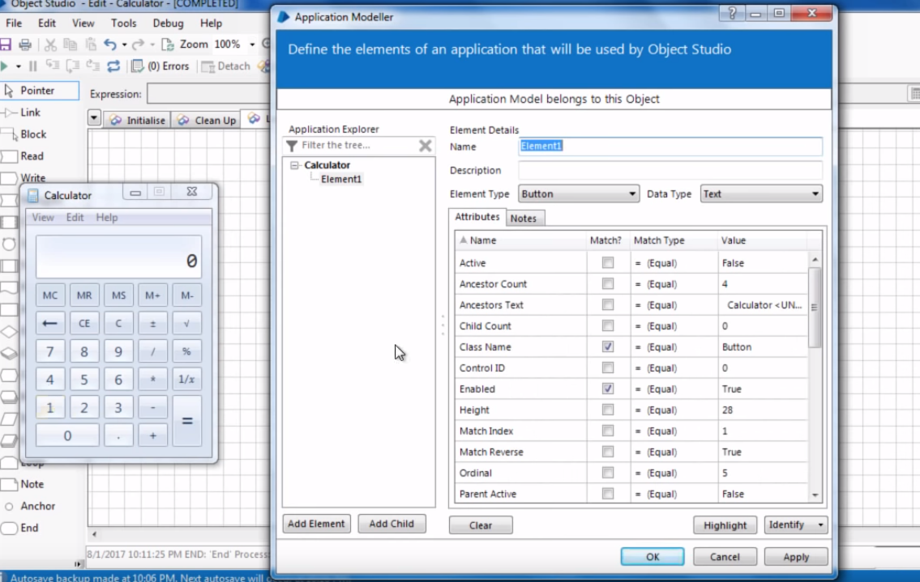

It opens up a dialog that shows all attributes using which this control can be identified.

Now it primarily select all default elements those are needed to be used to highlight and identify that element but to verify whether it select all required attribute user can use highlight button to verify whether element is been highlight using selected attributes. If not then among the identified attributes select those using which element can be identified individually. As in the above case using selected attributes get fails to identify the particular element hence one of the attribute ordinal number is been used which is grabbed by windows only by blue prism, to specifically identify the element.

Ordinal number – specifies the arrangement of element on application. As in this case Ordinal number of 1 is 5 so ordinal number of MC would be 1 and 6 would be 15.

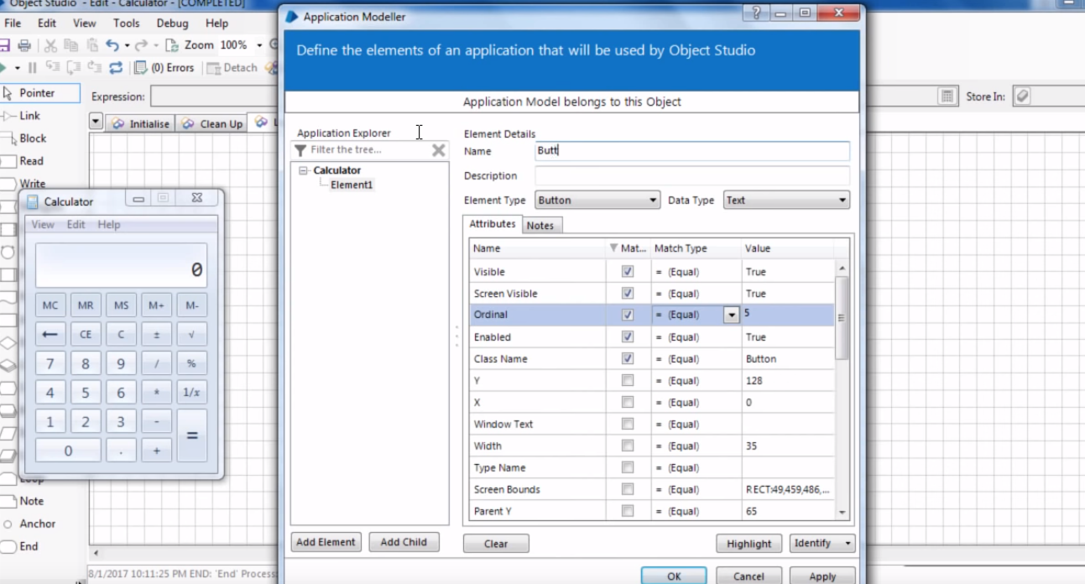

Select ordinal number and click highlight to verify that whether the control is been highlighted or not.

1. Grab other buttons as well like this –

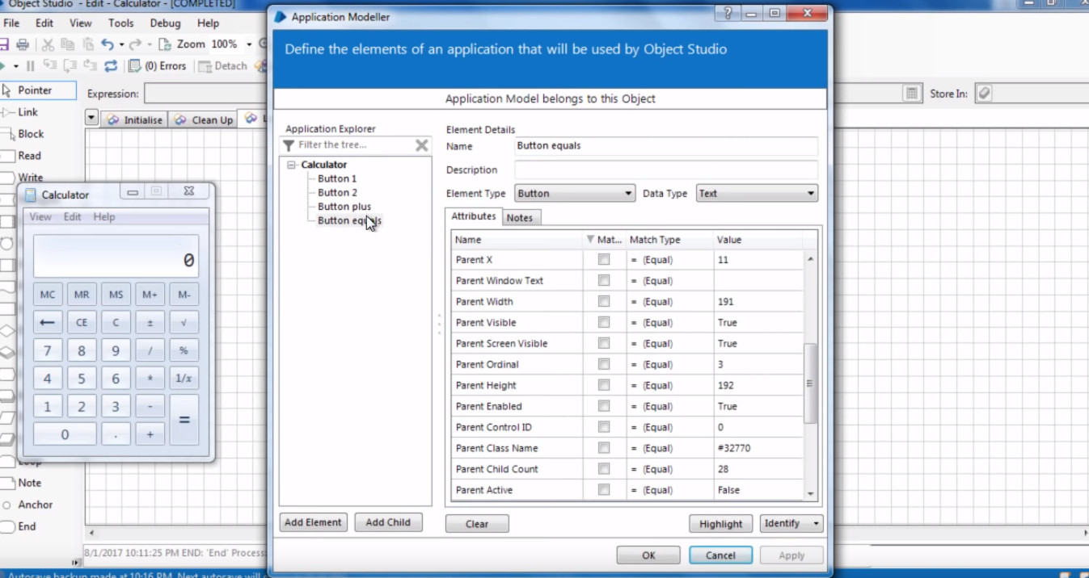

1. Now add new tab to object studio called Click button-1. Add navigate stage and fill in like below-

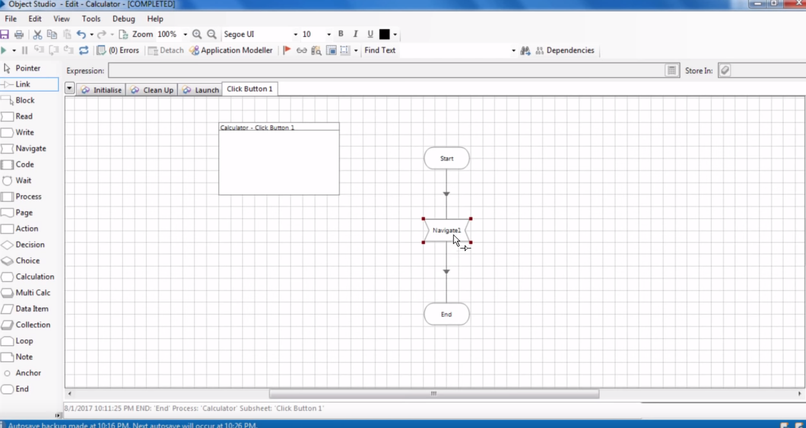

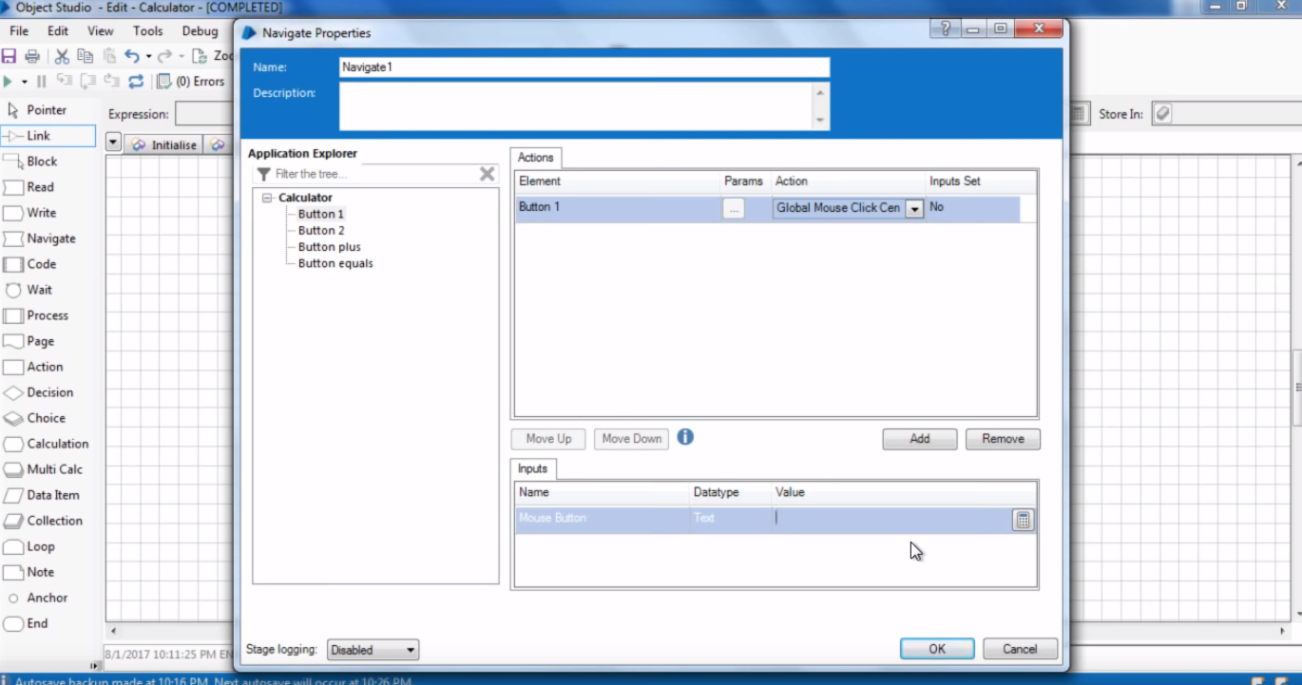

Global Mouse Click and Center Mouse Click – In Global mouse click we need to specify x and y co-ordinates where we need to click on the element on center mouse click it does not ask for those co-ordinates and by default click on the center of the element. But here it ask for one thing that is click button which specifies we need which click left/right.

We can specify that by simply writing left / right in double quotes here or leave it blank as default is left click.

1. Create other actions similarly –

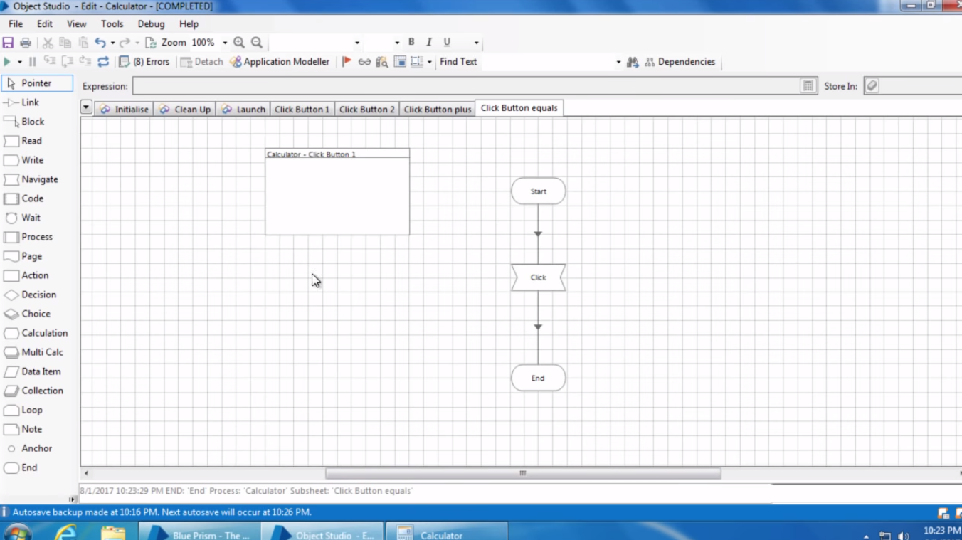

1. Save all actions in object studio and open process studio and add action stage and create a simple process using calculator VBO.

